A

**INDUSTRIAL TRAINING REPORT**

**ON**

**“Airline Management System Using Salesforce Admin”**

Submitted to: R. T. U, KOTA (RAJASTHAN)

in partial fulfillment of the requirement for the award of degree of

**BACHELOR OF TECHNOLOGY**



**Under the Supervision of: Submitted by:**

Pawan Sen Student Name: Tushar Sharma

Head of Department (CSE) RTU Roll No: 21EAYCS137

**ARYA COLLEGE OF ENGINEERING, JAIPUR**

RAJASTHAN TECHNICAL UNIVERSITY, KOTA (RAJASTHAN)

**SESSION: 2024-2025**

**ARYA COLLEGE OF ENGINEERING, JAIPUR**

DEPARTMENT OF COMPUTER SCIENCE & ENGINEERING

**Certificate of Completion**

This is to certify that the project entitled “**Airline Management System Using Salesforce Admin**” carried out by **Tushar Sharma**, a student of **Bachelor of Technology**, **7th SEM**, of **ARYA College of Engineering, Kukas, Jaipur**, at “**Learn And Build”**, near Gopalpura Police Station, this project is done under the supervision of Shiv Kumar Shakya, 7th semester of B.TECH.

**Project In charge: Name of Student: Tushar Sharma**

**Shiv Kumar Shakya B.TECH 7th Semester**

**ARYA COLLEGE OF ENGINEERING, JAIPUR**

DEPARTMENT OF COMPUTER SCIENCE & ENGINEERING

**Certificate of Completion**

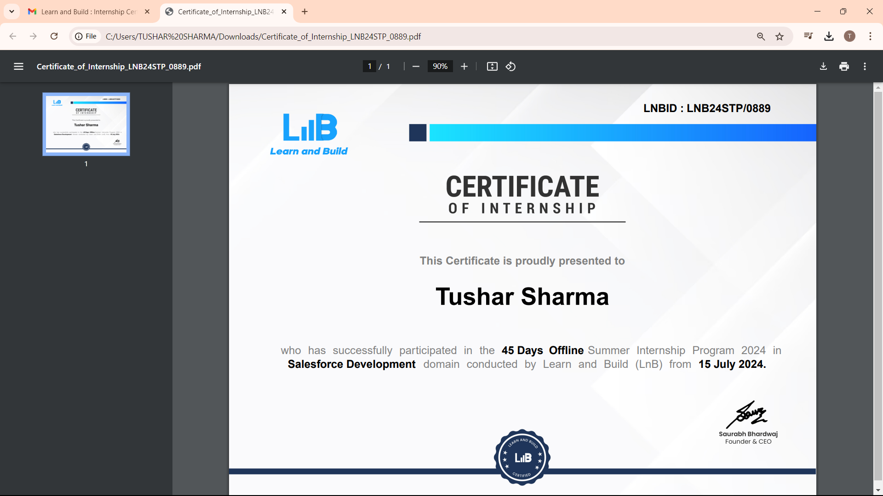

**Project In charge: Name of Student: Tushar Sharma**

**Shiv Kumar Shakya B.TECH 7th Semester**

**DECLARATION BY THE CANDIDATE**

I, **Tushar Sharma**, hereby declare that the project work entitled “**Airline Management System Using Salesforce Admin**” is an authenticated work carried out by me at “**Learn And Build**” for the partial fulfillment of the award of the degree of **B.TECH** and this work has not been submitted for similar purpose anywhere else.

**Date:** 22 October 2024 **Name:** Tushar Sharma

**Place:** Gopalpura, Jaipur **Roll No:** 21EAYCS137

**B.TECH 7th SEM**

**ACKNOWLEDGEMENT**

“Any serious and lasting achievement or success, one can never achieve without the help, guidance and co-operation of so many people involved in the work.”

I would like to express deep gratitude to **Mr. Pawan Sen**, Head of Department (CSE), Arya College of Engineering, Jaipur (Rajasthan) without whose permission the training would not be possible.

I am heartily thankful to those people who are involved directly or indirectly in this training for encouraging me whenever I needed their help despite their busy schedule.

**Tushar Sharma**

**21EAYCS137**

**B.TECH VII SEM**

**List of Tables**

|  |  |  |
| --- | --- | --- |
| **Sr No.** | **Title** | **Page No.** |
|  | **Certificate** | **1** |
|  | **Declaration** | **2** |
|  | **Acknowledgement** | **3** |
| **1.** | **Introduction** | **7** |
| **2.** | Salesforce Adminstrator | **8** |
|  | 2.1 Responsibility of Salesforce Administrator | 8 |
| **3.** | **Salesforce Developer** | **9** |
|  | 3.1 Responsibilities and roles of Salesforce Developer | 9 |
| **4.** | **Customer Relationship Management (CRM)** | **10** |
|  | 4.1 Key components of Salesforce CRM | 10 |
| **5** | **DataLoader** | **11** |
|  | 5.1 Key Components of Salesforce DataLoader | 12 |
| **6.** | **Lightning Web Components (LWC)** | **12** |
|  | 6.1 Key features of LWC | 13 |
| **7.** | **Trailheads and Training** | **14** |
|  | 7.1 Working of Trailheads | 14 |
| **8.** | **Project Description** | **15** |
|  | 8.1 Introduction | 15 |
|  | 8.2 Process | 15 |
|  | 8.3 Purpose of Project | 15 |
|  | 8.4 Requirement Analysis | 16 |
|  | 8.5 User Classes and Characteristics | 17 |
|  | 8.6 Project Code | 20 |
|  | **Conclusions** | **45** |

1. **INTRODUCTION**

Salesforce is a cloud-based customer relationship management (CRM) platform that helps organizations manage their sales, services, marketing, and other business processes. It provides a suite of tools and services that enable businesses to streamline and automate various aspects of their operation, ultimately improving customer relationships and increasing overall efficiency.

Salesforce, lnc. Is a famous American cloud-based software company that provides CRM services. Salesforce is a popular CRM tool for support, sales, and marketing teams worldwide.

Salesforce services allow businesses to use cloud technology to better connect with partners, customers, and potential customers.

A CRM platform helps you go deeper with all your metrics and data; you could also set up a dashboard that showcases your data visually. In addition to this, you can also have personalized outreach with automation. Another significant benefit is that a CRM platform can also improve customer service’s ability to help customer or a sales team’s outreach efforts.

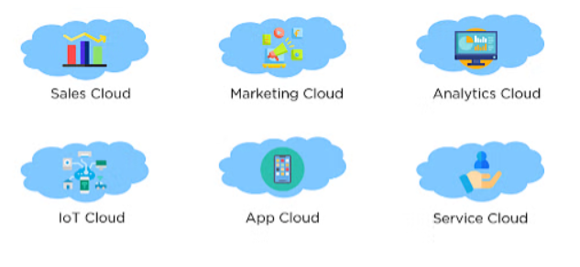

*Fig 1: Salesforce*

1. **Salesforce Admin**

A Salesforce Administrator often referred to as a Salesforce Admin, is a professional responsible for managing and maintaining the Salesforce platform within an organization. Salesforce is a widely used customer relationship management (CRM) platform that helps businesses streamline their sales, marketing, and customer service processes. Salesforce admin plays a critical role in optimizing the use of Salesforce to drive business success. They need a combination of technical skills, business acumen, and communication skills to effectively collaborate with different stakeholders within the organization.

**2.1 The Salesforce Admin plays a crucial role in configuring and customizing Salesforce to meet the specific needs of the organization. Their responsibilities include:**

1. **User Management:** Creating and managing user accounts, profiles, and permission sets to control access to different features and data within Salesforce.
2. **Data Management:** Importing, exporting, and maintaining data in Salesforce. This includes data cleaning, deduplication, and ensuring data integrity.
3. **Customization:** Configuring Salesforce to align with the organization’s business processes. This involves creating custom objects, fields, page layouts, and workflows to automate and optimize business operations.
4. **Security:** Implementing and maintaining security measures to protect sensitive data. This includes setting up role hierarchies, field- level security, ad other access controls.
5. **Automation:** Designing and implementing automation processes using tools like workflows, process builder, and flow to streamline repetitive task and business processes.
6. **Reports and Dashboards:** Creating and customizing reports and dashboards to provide insights into key performance indicators (KPIS) and helps users make informed decisions.
7. **Integration:** Connecting Salesforce with other systems and applications through integration tools and APIs to ensure seamless data flow and communication.
8. **Troubleshooting:** Identifying and resolving issues related to Salesforce functionality, data, or user access. This may involve working closely with the end-users and collaborating with Salesforce support if necessary.
9. **Training and Support:** Providing training too users on how to effectively use Salesforce and offering ongoing support to address questions and issues.

**3. Salesforce Developer**

A Salesforce Developer is a professional responsible to designing, coding, testing and custom solutions within the Salesforce platform. Salesforce, being a highly customizable and extensible CRM (Customer Relationship Management) platforms allows organizations to tailor it to their specific business needs. Salesforce Developers work with various programming languages and tools to create custom functionalities and applications on the Salesforce Platform.

Salesforce Developers need a sloid understanding of the Salesforce platform, its data model, and its various features. They should also be proficient in Apex, Visualforce, and other relevant technologies, Additionally, staying updated with the latest Salesforce releases and industry best practises is essential for a successful Salesforce Developer.

**3.1 Here are some key responsibilities and aspects of the role of a Salesforce Developer.**

1. **Customer Development:** Writing custom code to extend the capabilities of Salesforce. This involves using programming language such as Apex(Salesforce’s proprietary language) and visualforce (a markup language for creating custom user interfaces).
2. **Integration:** Building integrations between Salesforce and other external systems. This could involve connecting Salesforce with other applications, databases, or services to ensure seamless data flow and business process automation.
3. **Lightning Components:** Developing Lightning Components, which are reusable building blocks for developing applications on the Salesforce Lightning framework. Lightning Components are used to create modern and responsive user interfaces.
4. **Apex Triggers:** Creating Apex triggers to respond to specific events and automate processes within Salesforce. Triggers are used to execute custom logic when records are inserted, updated, or deleted.
5. **Visualforce Pages:** Designing and developing Visualforce pages to create custom user interfaces and enhance the user experience within Salesforce Classic.
6. **Salesforce Lightning Web Components:** Developing components using the more modern Lightning Web Components frameworks, which is part of the Salesforce Lightning platform.
7. **Testing:** Writing and executing unit tests to ensure the quality and reliability of the custom code. Salesforce has a strong emphasis on code coverage and requires a certain percentage of code to be covered by tests.
8. **Security:** Implementing security best practices to protect data and ensure that custom solutions adhere to Salesforce standards.
9. **Collaborations:** Collaborating with Salesforce Administrator, business analyst, and other stakeholders to understand requirements and design solutions that meet business needs.

**4. Customer Relationship Management (CRM)**

CRM stands for “Customer Relationship Management” and salesforce is a leading provider of CRM software. In the context of Salesforce, CRM refers to the suite of tools and features designed to help businesses manage their relationships and interactions with customers and potential customers. Salesforce CRM encompasses a wide range of functionalities that support various aspects of the customer lifecycle, including sales, marketing, customer service, and more.

**4.1 Key components of Salesforce CRM include:**

1. **Sales Cloud:** This module is focused on sales automation and management. It includes tools for lead and opportunity management, contact and account management, sales forecasting, and collaboration among sales team.
2. **Service Cloud:** Service Cloud is designed to support customer service and helpdesk functions. It includes features for case management, knowledge base, customer portals, and omnichannel support to deliver a seamless customer service experience.
3. **Marketing Cloud:** Salesforce Marketing cloud provides tools for marketing automation, email marketing, social media marketing, and analytics. It helps organizations create targeted marketing campaigns and track their effectiveness.
4. **Commerce Cloud:** Formerly known as Demandware, Salesforce Commerce Cloud is an e-commerce platform that enables businesses to create personalized and connected shopping experiences for their customers.
5. **Analytics Cloud:** Salesforce Analytics enables organizations to analyze and visualize data for better decision-making.
6. **IoT Cloud:** This module is designed to connect and analyze data from the Internet of Thing (IoT) devices.

**5. Dataloader**

Data Loader is a powerful and free data management tool provided by Salesforce for importing, exporting, and deleting data in Salesforce. It’s a desktop application that allows users to perform bulk data operations, making it easier to manage large volumes of data within the Salesforce platform.

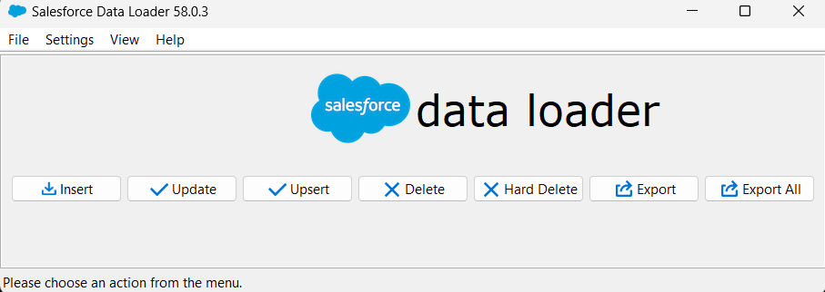

*Fig 2: DataLoader*

**5.1 Key components of Salesforce DataLoader include:**

1. **Data Import:** Data Loader allows users to insert, update, delete, upsert (update and insert), or delete records in Salesforce. It supports bulk import operations, making it efficient for dealing with large datasets.
2. **Data Exports:** Users can extract data from Salesforce objects and exports it to CSV files. This is useful for creating backups, transferring data between Salesforce instances, or performing data analysis outside of the Salesforce environment.
3. **Data Deletion:** Data Loader can be used to delete records from Salesforce objects in bulk. This is helpful for cleaning up data or removing obsolete record.
4. **CSV File Support:** Data Loader works with data in CSV (common-separated values) file format, a common and widely supported format for representing tabular data.
5. **Command-Line Interfaces:** Data Loader provides a command-line interface for users who prefer to automate data management tasks. This is especially useful for scheduling loads or integrating Data Loader in automated processes.
6. **Data Transformation:** Users can map fields between the CSV file and Salesforce objects, allowing for data transformation during import or export. This ensures that data is correctly mapped to the appropriate Salesforce fields.
7. **Error Handling:** Data Loader generates error file that provide information about any records that failed to process during an import. This allows users to review and address errors efficiently.
8. **Parallel Processing:** Data Loader supports parallel processing, enabling faster data operations by splitting large datasets into smaller batches.

**6. Lightning Web Components (LWC)**

LWC stands for Lightning Web Components, a programming model and framework developed by Salesforce for building web components on the Lightning Platform. Lightning Web Components are a modern and lightweight way to create user interfaces for Salesforce applications. They leverage standard web technologies such as HTML, JavaScript, and CSS and follow the Web Components standards. It provides a more developer-friendly and efficient way to build UI components compared to the previous Aura Components model.

**6.1 Key Features and concepts of Lightning Web Components (LWC) include:**

1. **Web Standards Compliance:**

* LWC adheres to the web standards defined by the World Wide Web Consortium (W3C) for Web Components.
* Uses modern JavaScript ECMAScript 6 (ES6) syntax.

1. **Components-Based Architecture:**

* Encourages the building of modular and reusable components.
* Components can be easily composed and nested within each other.

1. **Data Binding:**

* Supports two-ways data binding, allowing changes in the component’s state to automatically reflect in the user interface and vice versa.

1. **Event Handling:**

* Components can communicate with each other using events.
* Simplifies the handling of user interactions and data flow between components.

1. **Lightning Data Services:**

* Integrates with Lightning Data Service to simplify data retrieval, manipulation, and caching.
* Provides a standard way to work with Salesforce data without the need for custom Apex code.

1. **Integration with Aura Components:**

* Can coexist with existing Aura components, allowing for a gradual migration to the new Lightning Web Components model.

1. **Performance:**

* Lightning Web Components are designed to be efficient and performant.
* Take advantages to browser capabilities and optimizes rendering for a smoother user experience.

1. **Open Source:**

* Lightning Web Components open-source framework is available on GitHub, allowing developers to contribute and participate in the evolution of the framework.

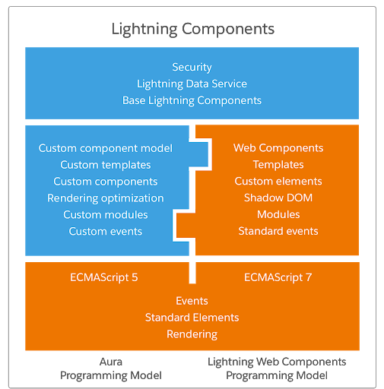

*Fig 3: Lightning Web Component*

**7. Trailheads and Training**

Trailheads is Salesforce’s free online learning platform that provides a variety of interactive and hands-on learning paths, modules, and projects to help individuals learn and master Salesforce skills. It is designed to cater to users of all levels, from beginners to experienced professionals. Trailheads offers a gamified learning experience, allowing users to earn badges and points as they complete challenge and projects.

**7.1 Working of Trailheads include:**

1. **Learning Paths:** Guided trails and modules covering specific topics, ranging from beginner to advanced levels.
2. **Projects:** Hands-on, real-world projects that allows users to apply what they’ve learned in a practical setting.
3. **Superbadges:** Advanced, scenario-based challenges that tests a user’s understanding of specific concepts and skills.
4. **Badges and Points:** Users earn badges and accumulate points for completing modules, trails, and challenges.
5. **Community and Collaboration:** Trailheads includes a community aspect where users can connect with each other, ask questions, and share knowledge.

**8. Project Description**

**8.1 Introduction**

In this project we are to discuss about the Airline Management System that manages Flight, Flight Schedule, Pilot, Pilot Schedule. This project is based on Salesforce Administrator.

In Airline Management System we will managing the flight, flight schedule with different fields, pilot details, pilot schedule. In this there is a report and dashboard that represent the record of a flight as well as the graph of a flight that when which flight will arrive form our source to destination. It have many different conditions using validation rule. We have create different fields which shows the different entry of every details related to a flight.

**8.2 Process**

* First fill the details of a flight, that which flight company you want to book.
* After that fill the details of source and destination as well as arrival and departure date time.
* Details of a pilot which have the pilot first and last name, pilot mail id and many other details.

**8.3 Purpose of Project**

* To save the time of customer for booking the flight.
* Anytime from any where customer can book the flight.
* If the flight will get cancelled or get delayed then the customer will immediately receive the mail, that the flight will get cancelled or the flight is delayed before the 1 hour of flight arrival.
* Even in this the customer will also get the details of pilot.
* The customer can see that how many members are there in that flight.
* The customer will provide the every details of customer related to the flight as well as pilot also.

**8.4 Requirement Analysis**

**8.4.1 Hardware Requirement**

* Laptop/Computer

**8.4.2 Software Requirement**

* Login to the Salesforce on Salesforce.com.
* Need Salesforce ID/Username and password.
* Setup of Salesforce Administrator.

**8.4.3 Functional Requirement**

1. **Custom Objects:**

* Create custom objects for flight, flight schedule, pilot, pilot schedule.

1. **Fields:**

* Different fields for flight, flight schedule, pilot, pilot schedule. Using different datatype for these fields.

1. **Page Layouts:**

* Page Layout helps to set the page which is suitable for the customer.

1. **Workflow and Processes:**

* Implement automated workflows for flight status updates, reservation confirmations, and other business processes.

1. **Process Builder:**

* It will implement the many condition at a single time and even send the mail to the customer as well as pilot of flight detailed.

1. **Mail Template:**

* In this mail template we have design our own template through which the customer get mail when the flight will get cancelled, or get delayed.

1. **Security:**

* No other person will able to see the other customer details.

1. **Report and Dashboard:**

* In report there is a schedule of every flight. That how many entries have got fill for current flight.
* And dashboard represent the different graph for flight.

**8.5 User Classes and Characteristics**

**8.5.1 Class Diagram**

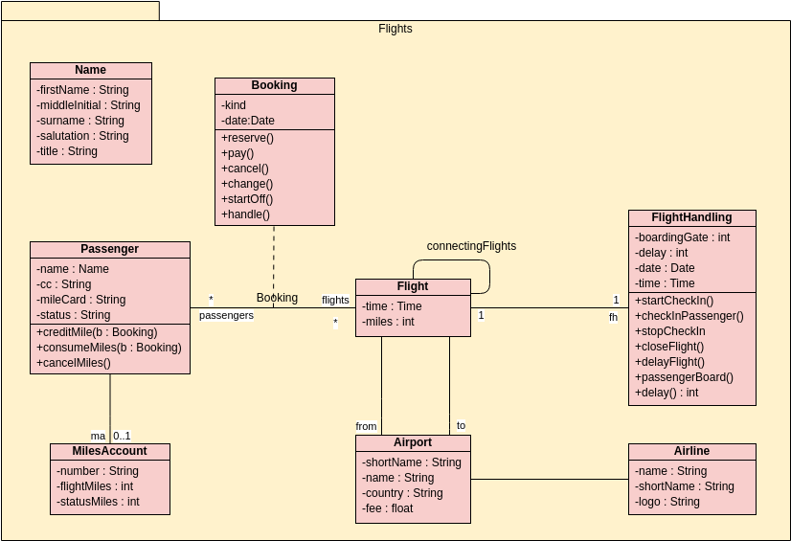

*Fig 4: Class Diagram of Airlines Management System*

**8.5.2 Use Case Diagram**

 *Fig 3: Use Case Diagram of Airlines Management System*

**8.5.3 Activity Diagram**

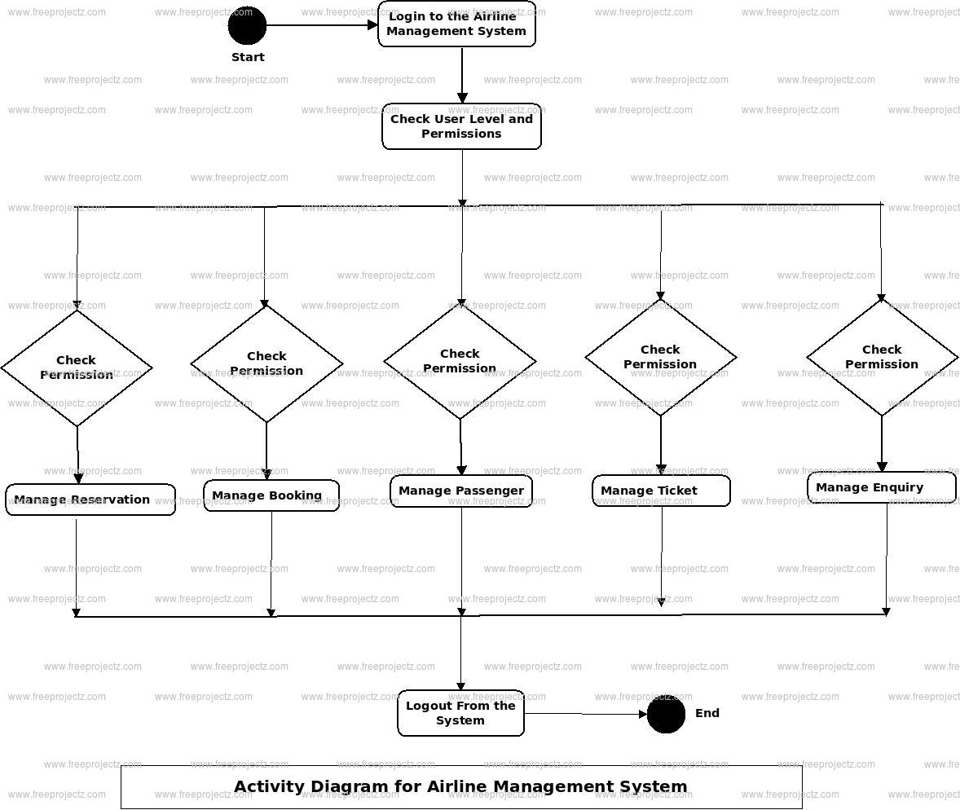

*Fig 5: Activity Diagram of Airlines Management System*

**8.6 Project Code**

* Airlines Management System Manages the flights, flights schedules, pilots, pilots schedules.

**1] App Name:**

* Airlines Management System Add a flight company logo

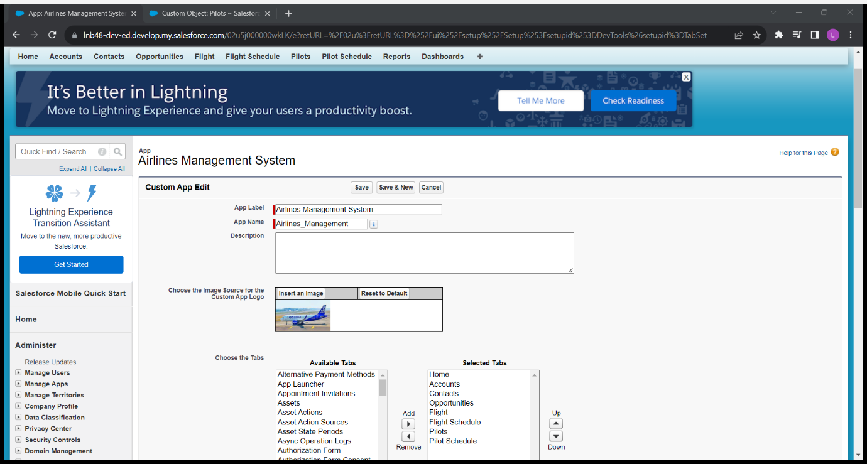

*Fig 6: To create Apps*

**2]Object: Flight**

* Create new flight with flight ID, flight name like Go-102, and Flight Company

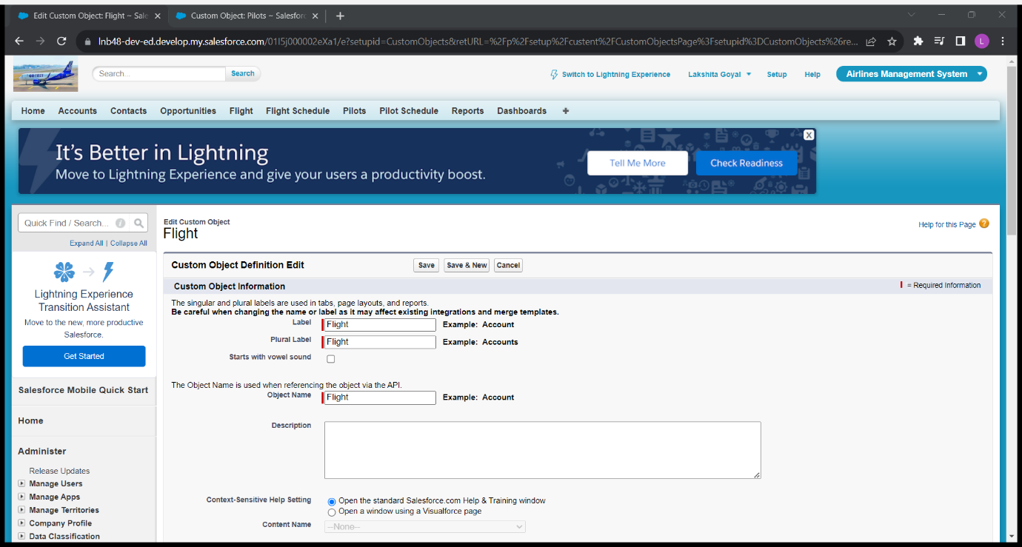

*Fig 7: Flight object*

* **Requirement:**

A] Show all schedules of this flight in its related list

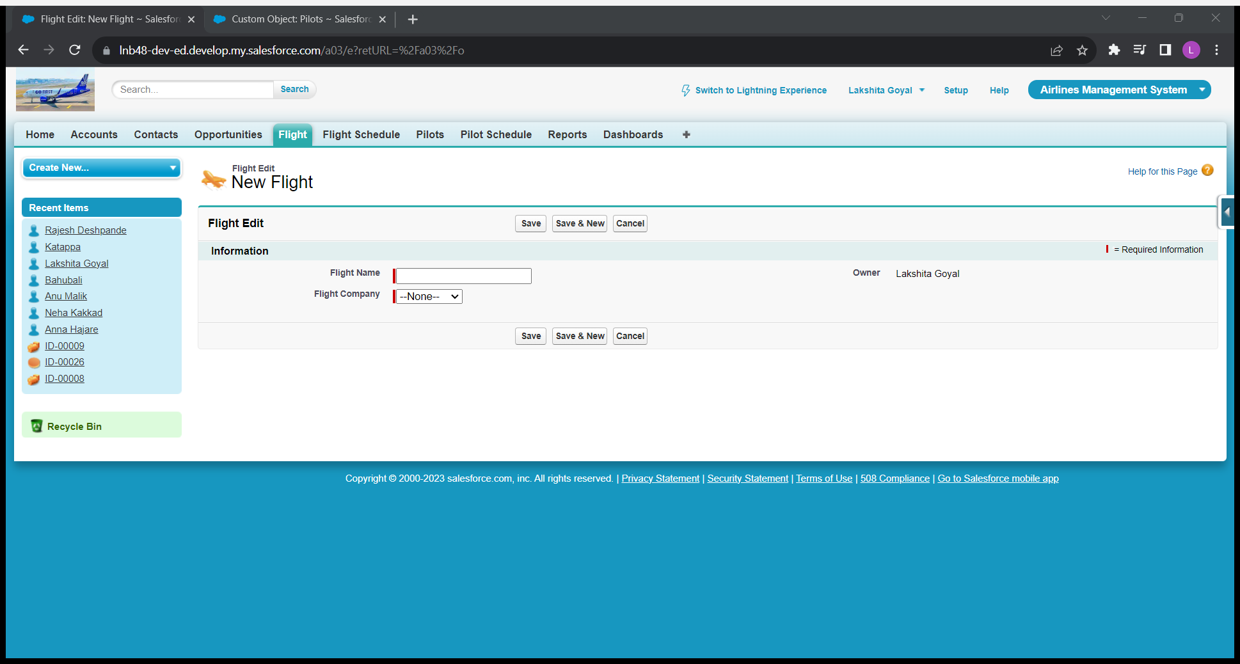

*Fig 8: Flight Object details*

**3]Object: Flight Schedule**

* This object is responsible for flight schedule

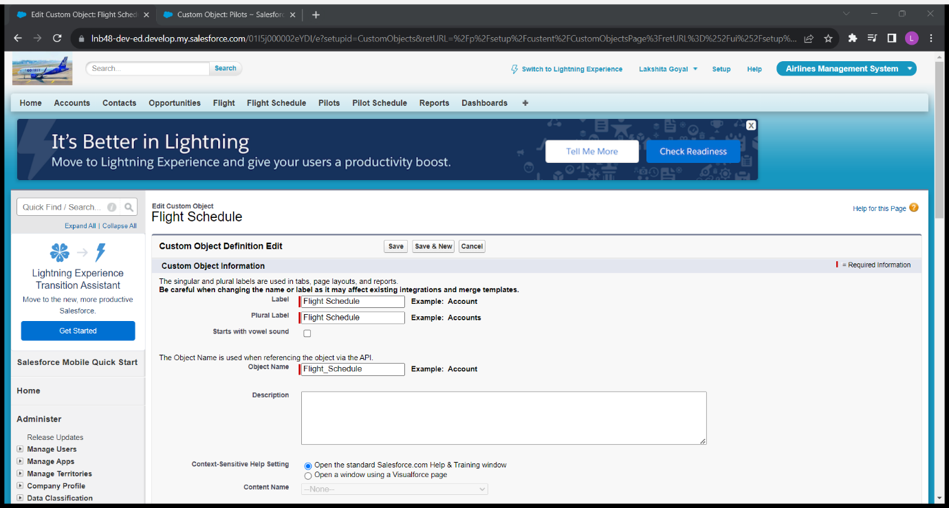

*Fig 9: Flight Schedule*

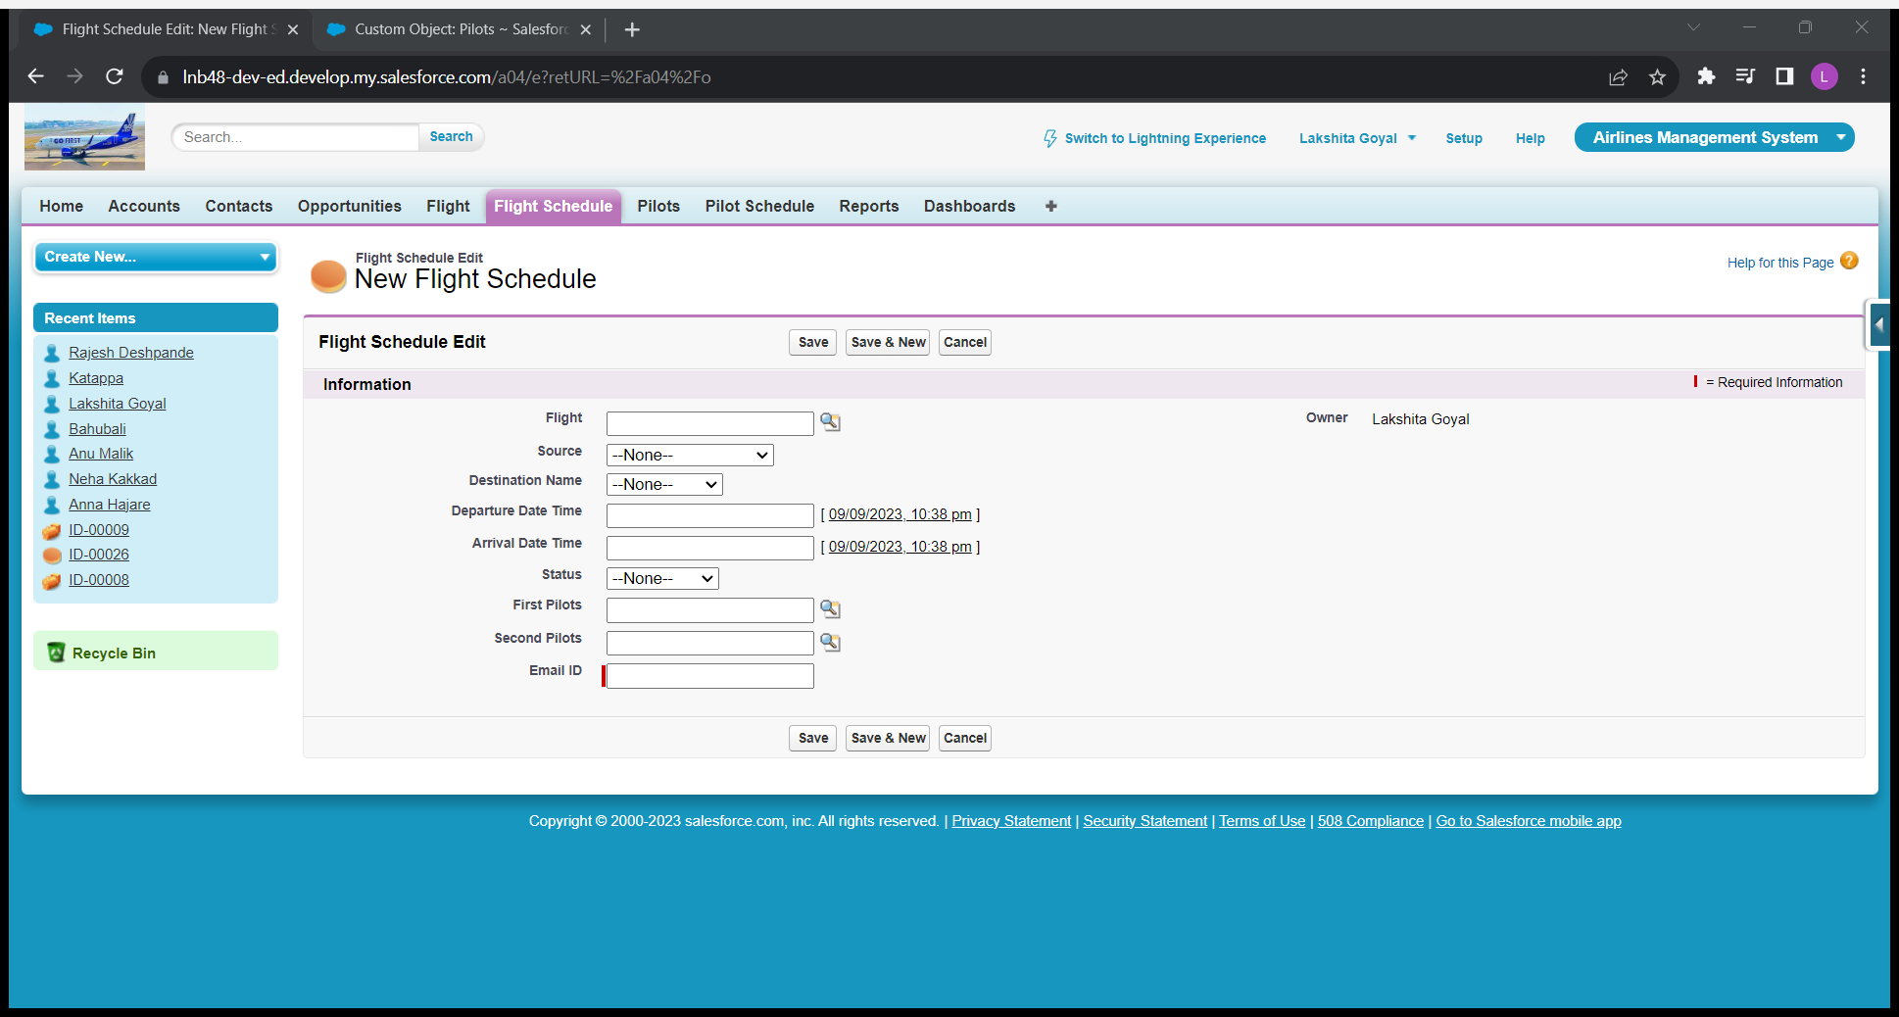

*Fig 10: Design of Flight Schedule*

* **Requirements:**

A] Source Name and Destination name must not be same=

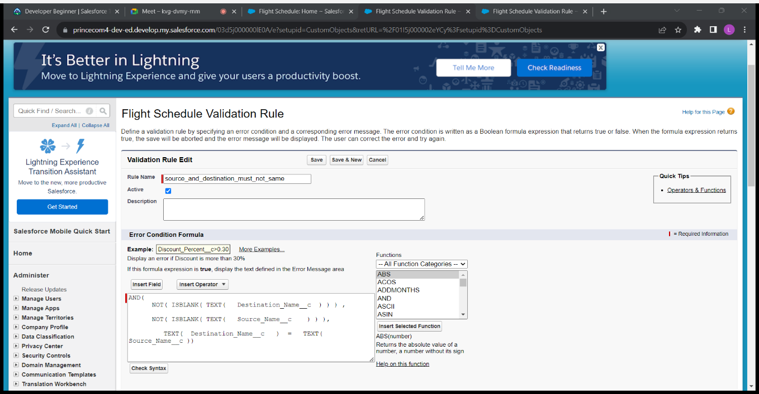

*Fig 11: Formula for Source and destination must not be equal*

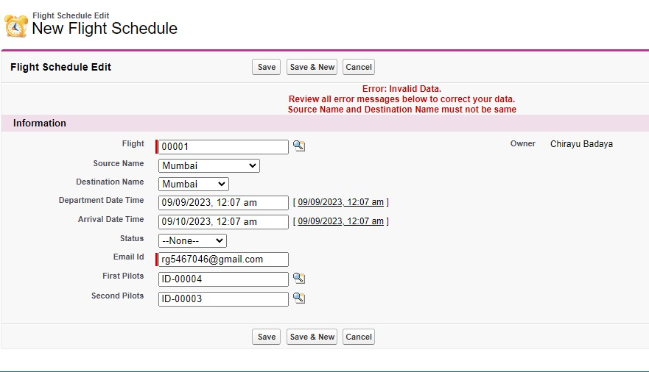

*Fig 12: When there is error*

B] Departure Date Time and Arrival Date Time must not be same=

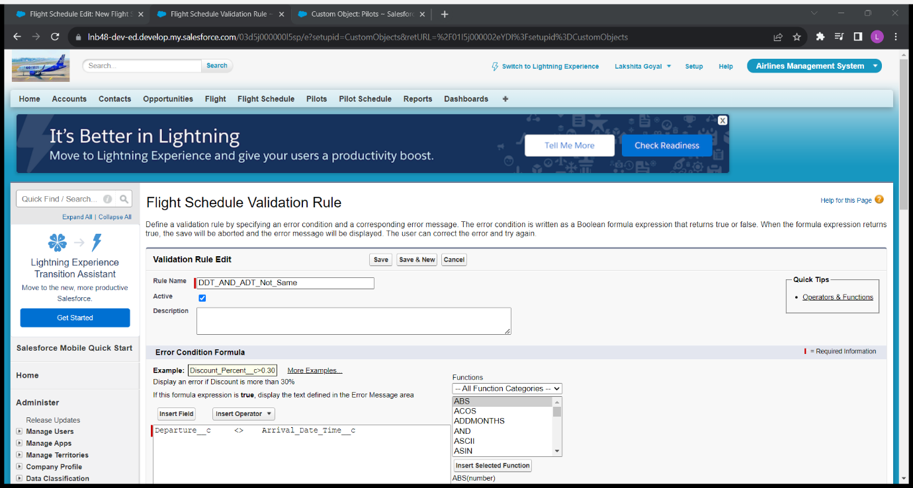

*Fig 13: Formula for Departure and Arrival Date Time must not be equal*

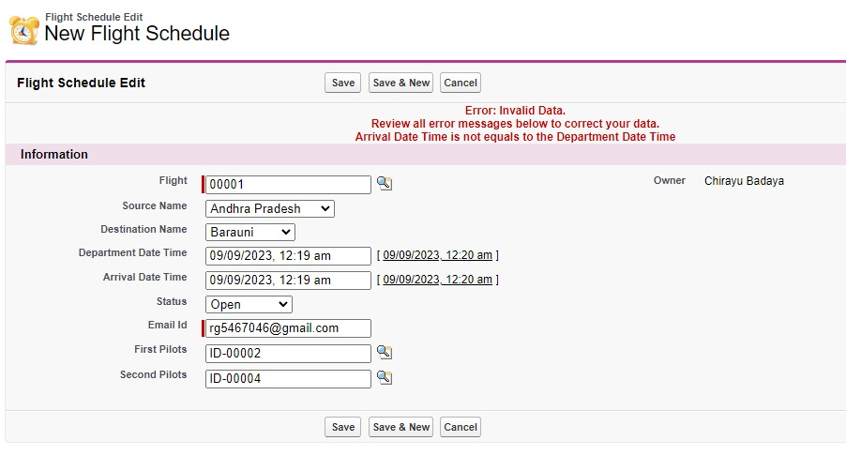

*Fig 14: When departure and arrival date time is equal*

D] When a new flight schedule record is created, default status with be OPEN=

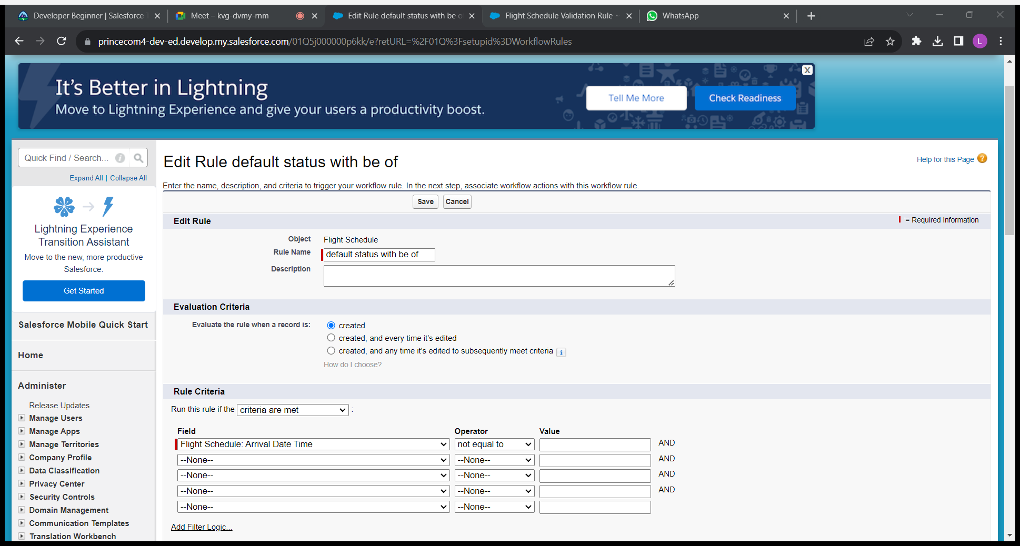

*Fig 15: Workflow rule for arrival date time not equal to blank*

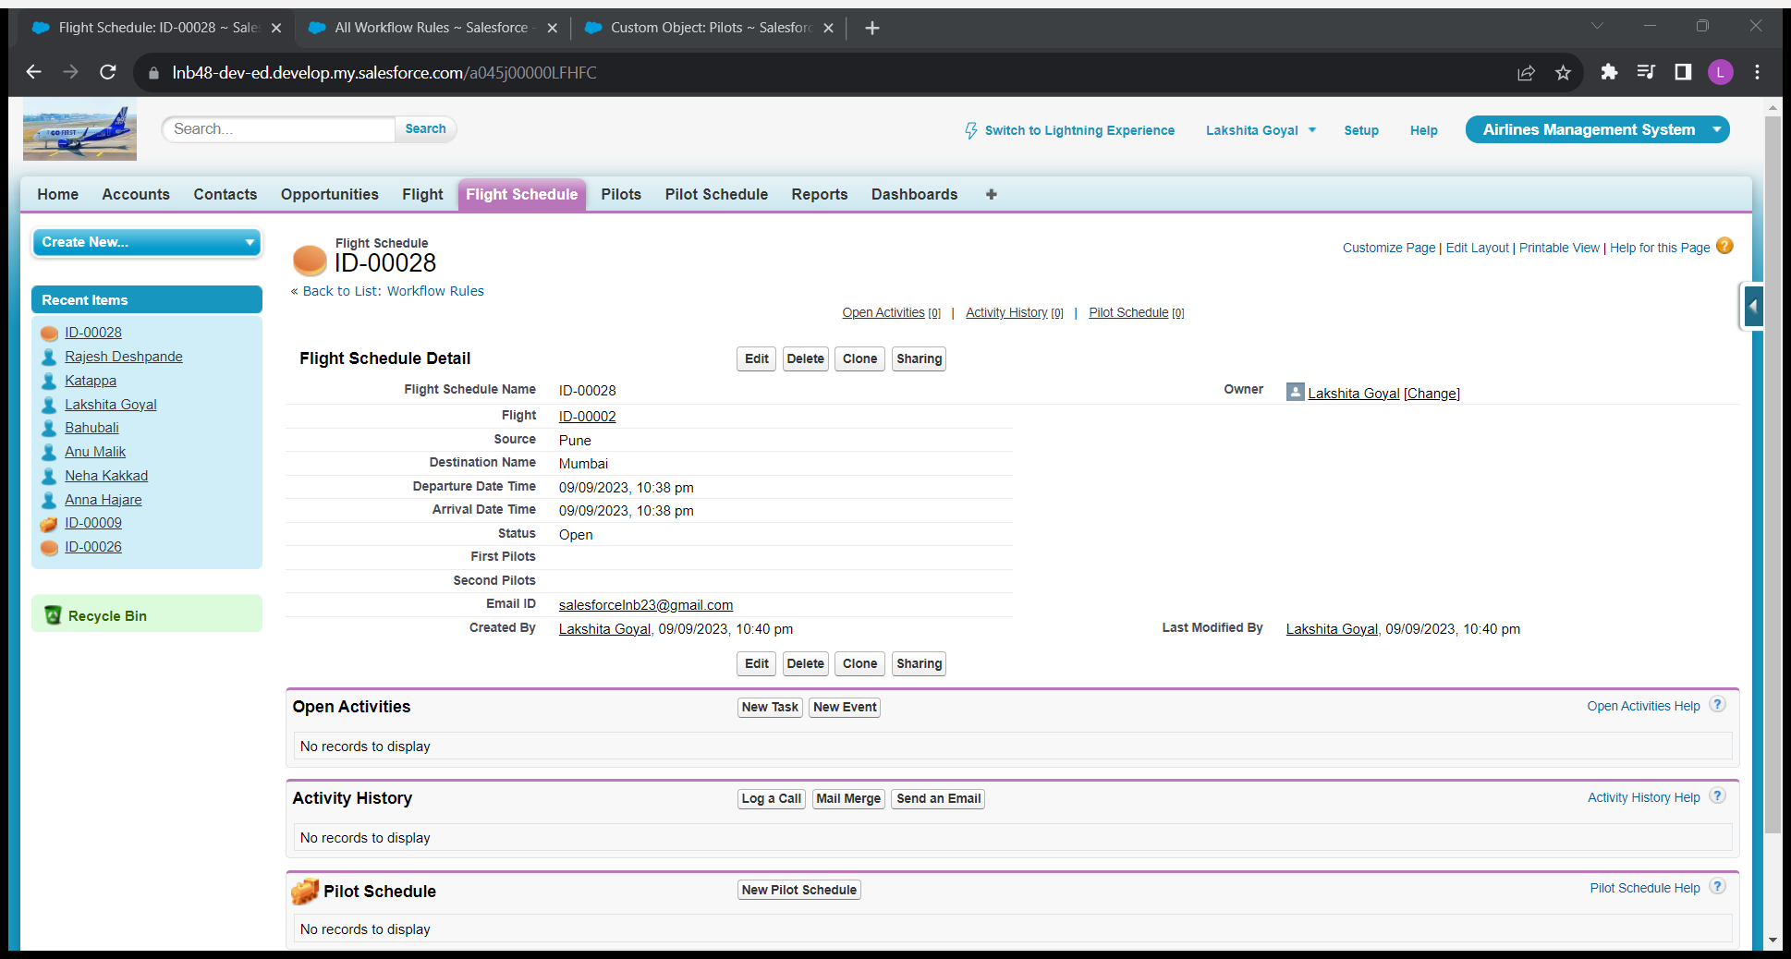

*Fig 16: When the default status will be OPEN*

E] When flight is ready to depart, status should be IN PROGRESS=

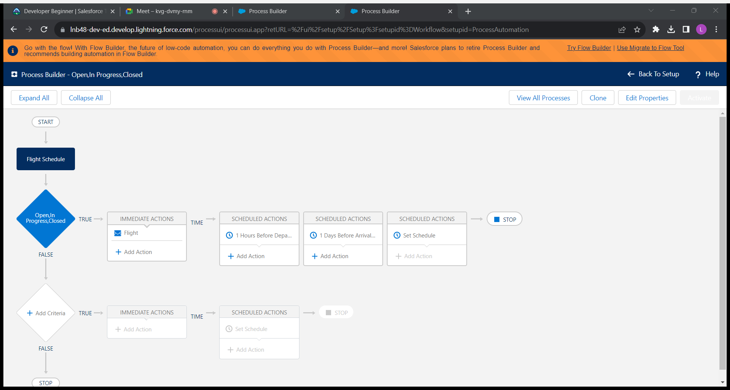

*Fig 17: Process Builder for the flight when flight should be IN PROGESS*

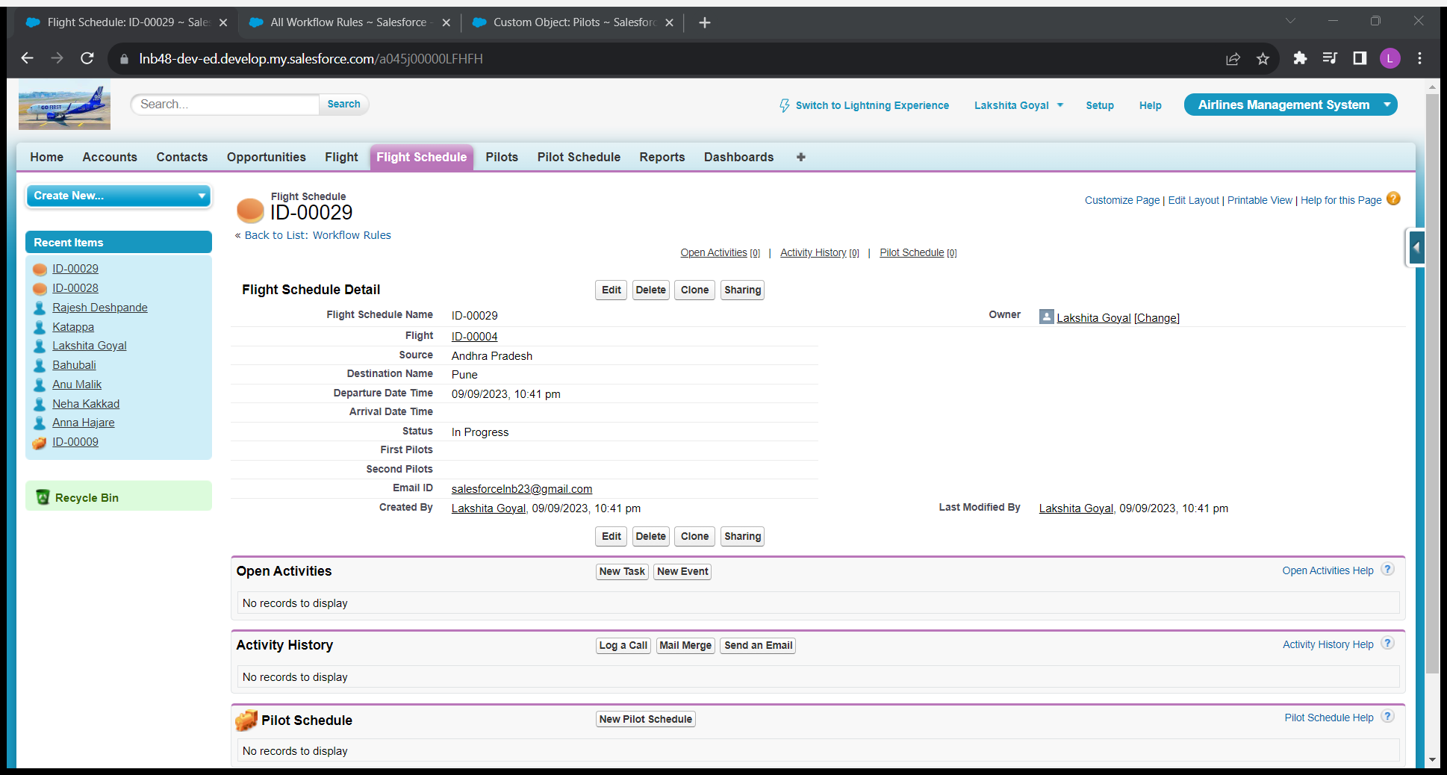

*Fig 18: When the flight schedule is IN PROGESS*

F] When flight arrives, then status should CLOSED=



*Fig 19: Process Builder when the flight should be CLOSED*

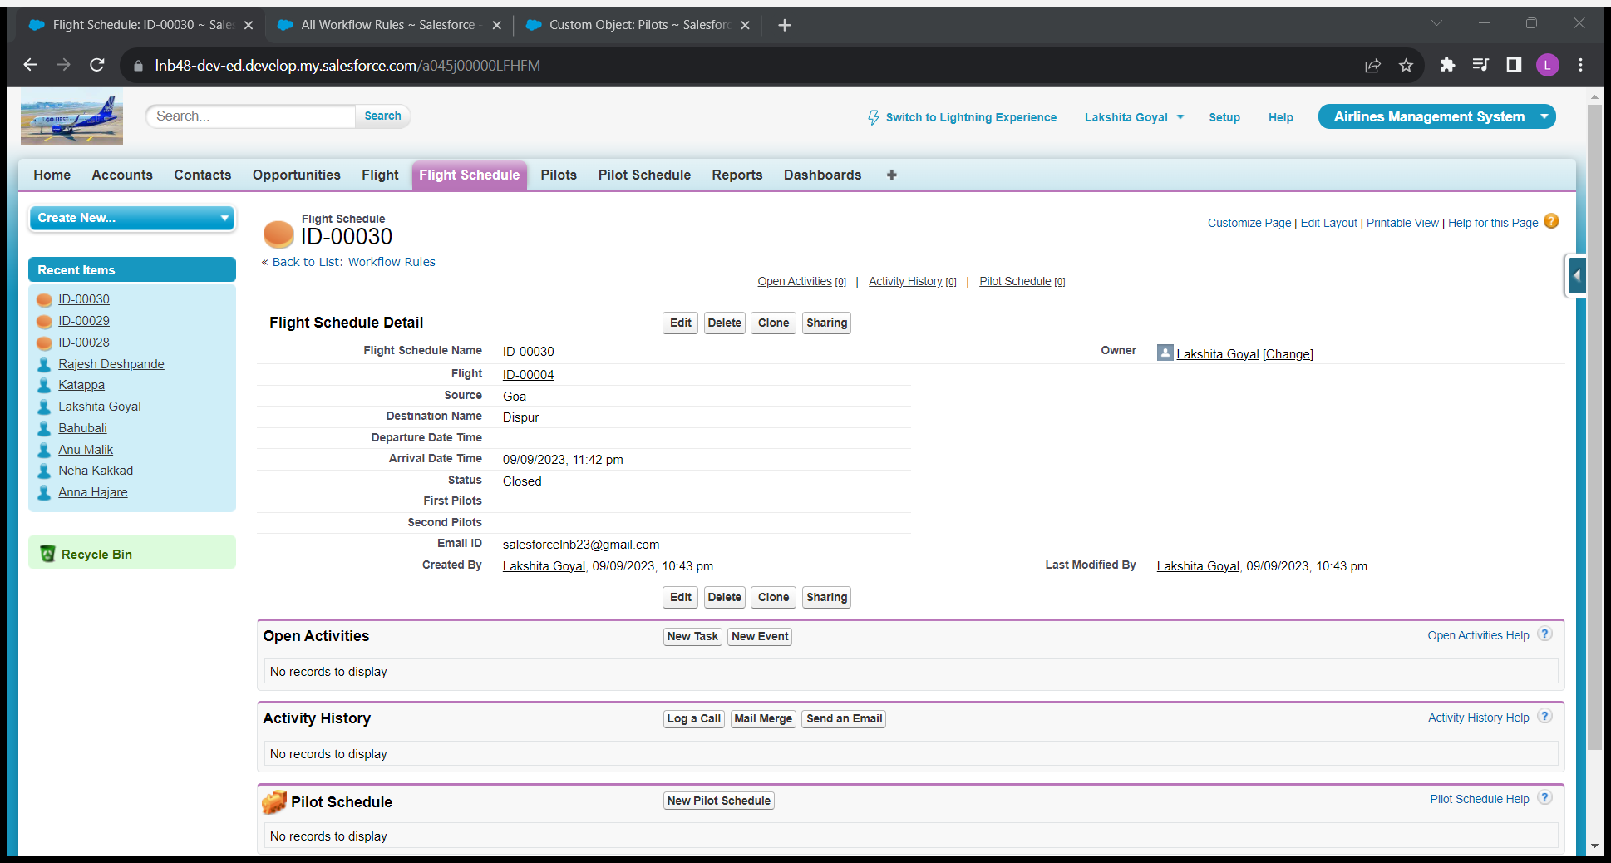

*Fig 20: The flight schedule is CLOSED*

H] Send an email to system admin and to pilots if flight schedule cancelled.

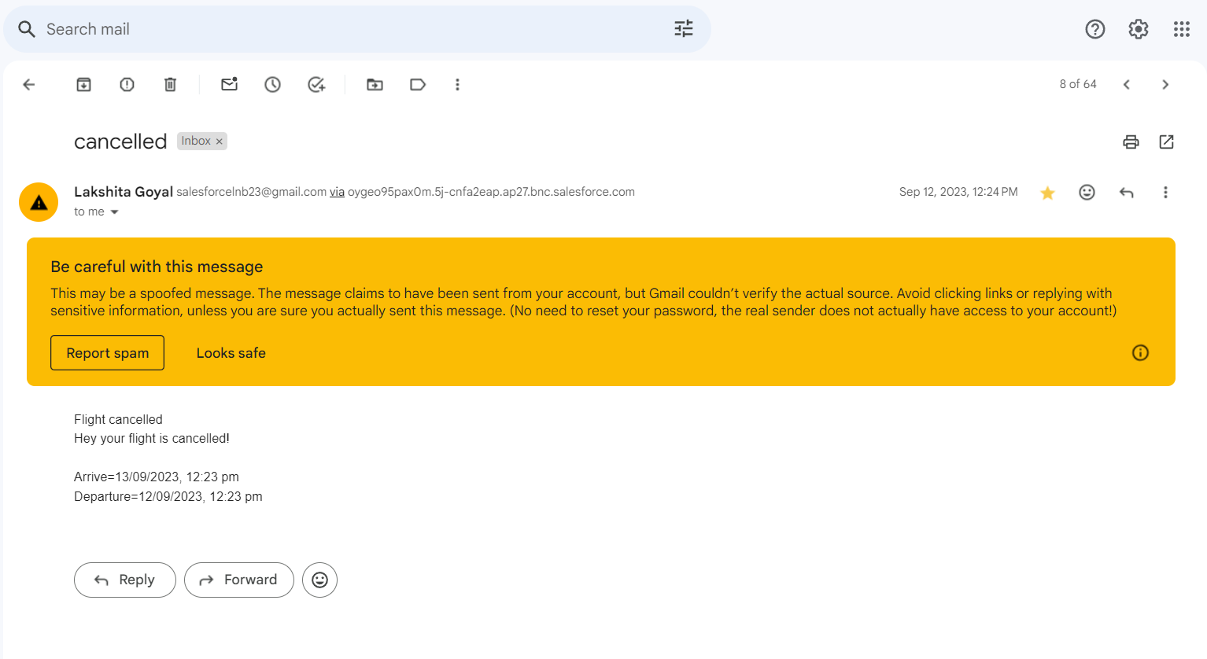

*Fig 21: When email is send to the pilot, when flight is CANCELLED*

**4]Pilots=**

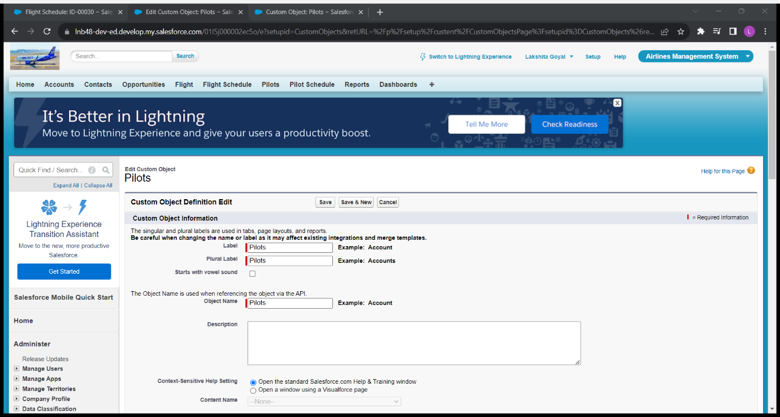

*Fig 22: Pilot Object*

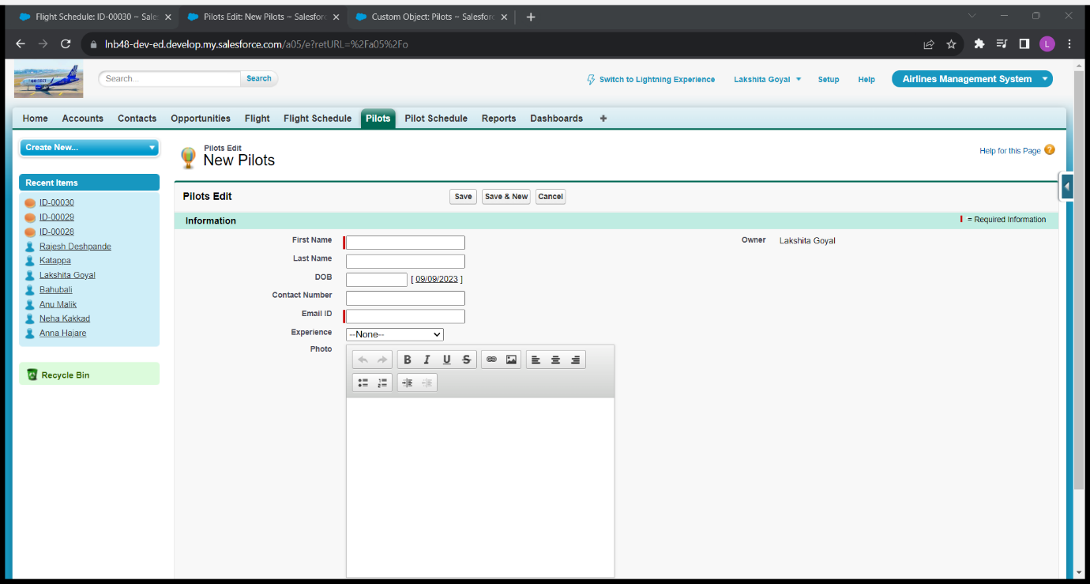

*Fig 23: Page for Pilot*

* Requirement:

A] First Name and Last Name must not be same=

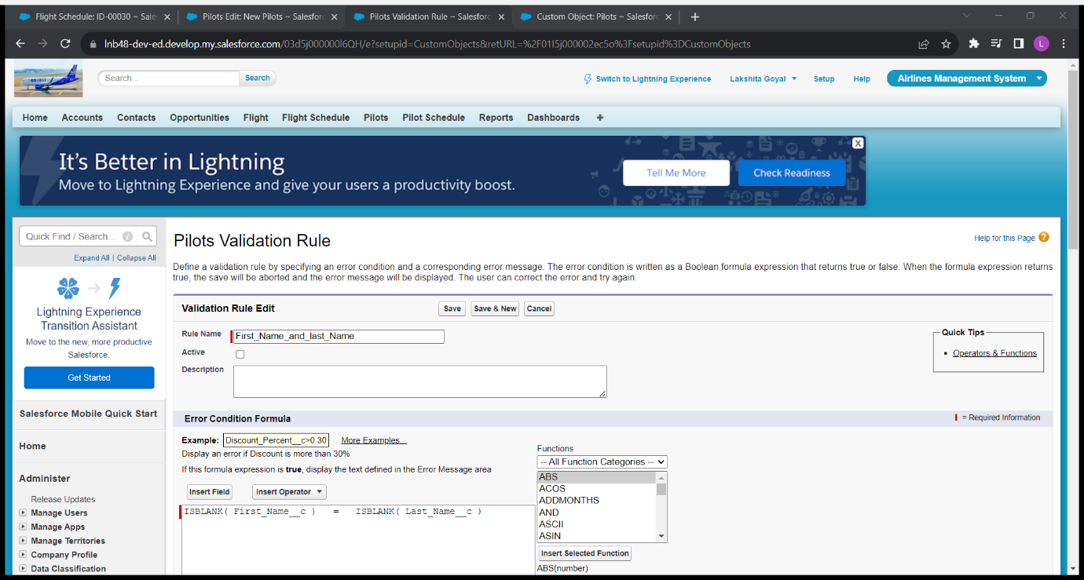

*Fig 24: Formula for first name and last name must not be same*

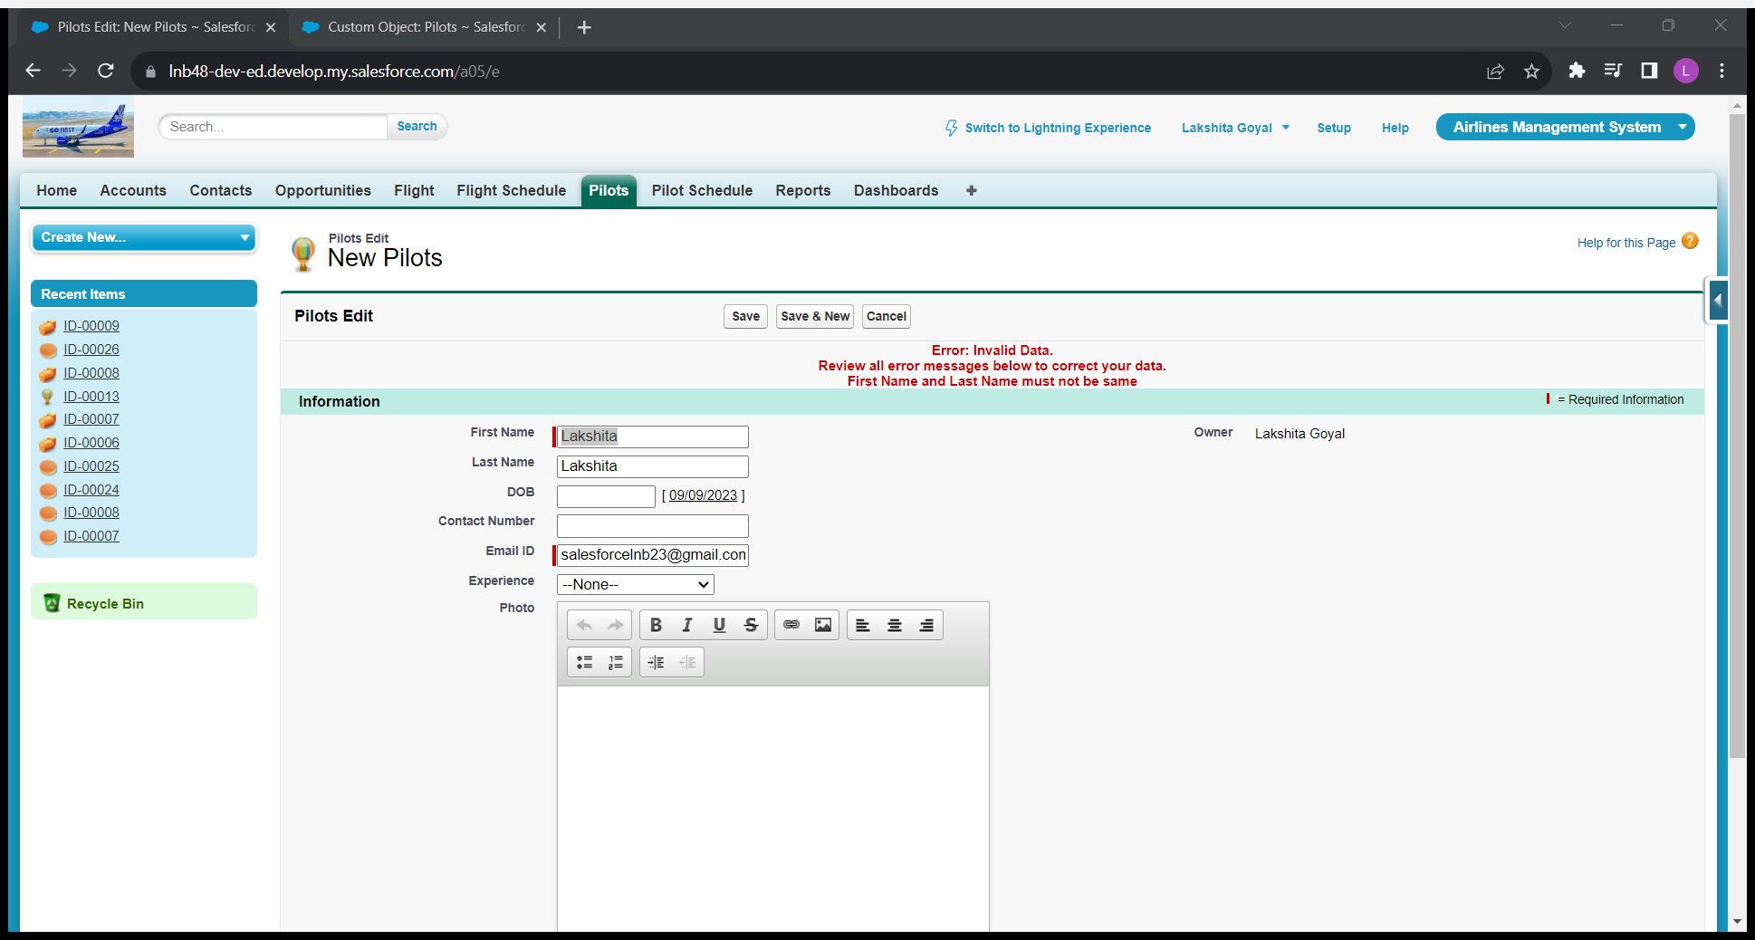

*Fig 25: When the first name and last name is same*

B] Age must be greater or equals to 18=

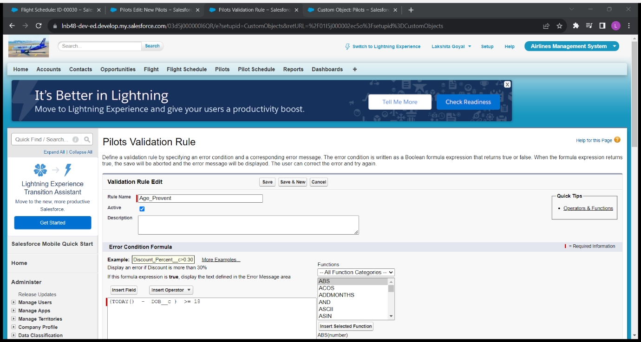

*Fig 26: Formula for age should be greater than 18*

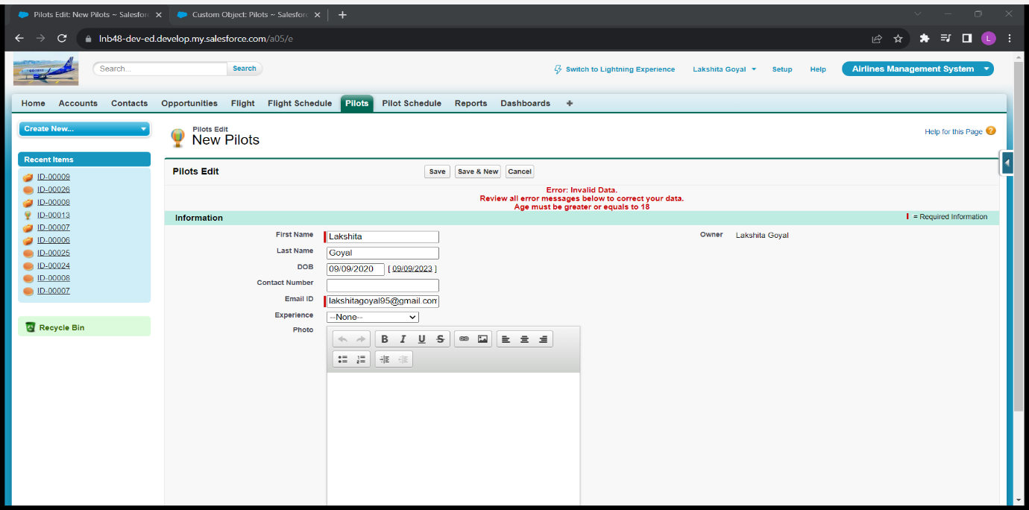

*Fig 27: Error when age is less than 18*

5]Pilot Schedule=

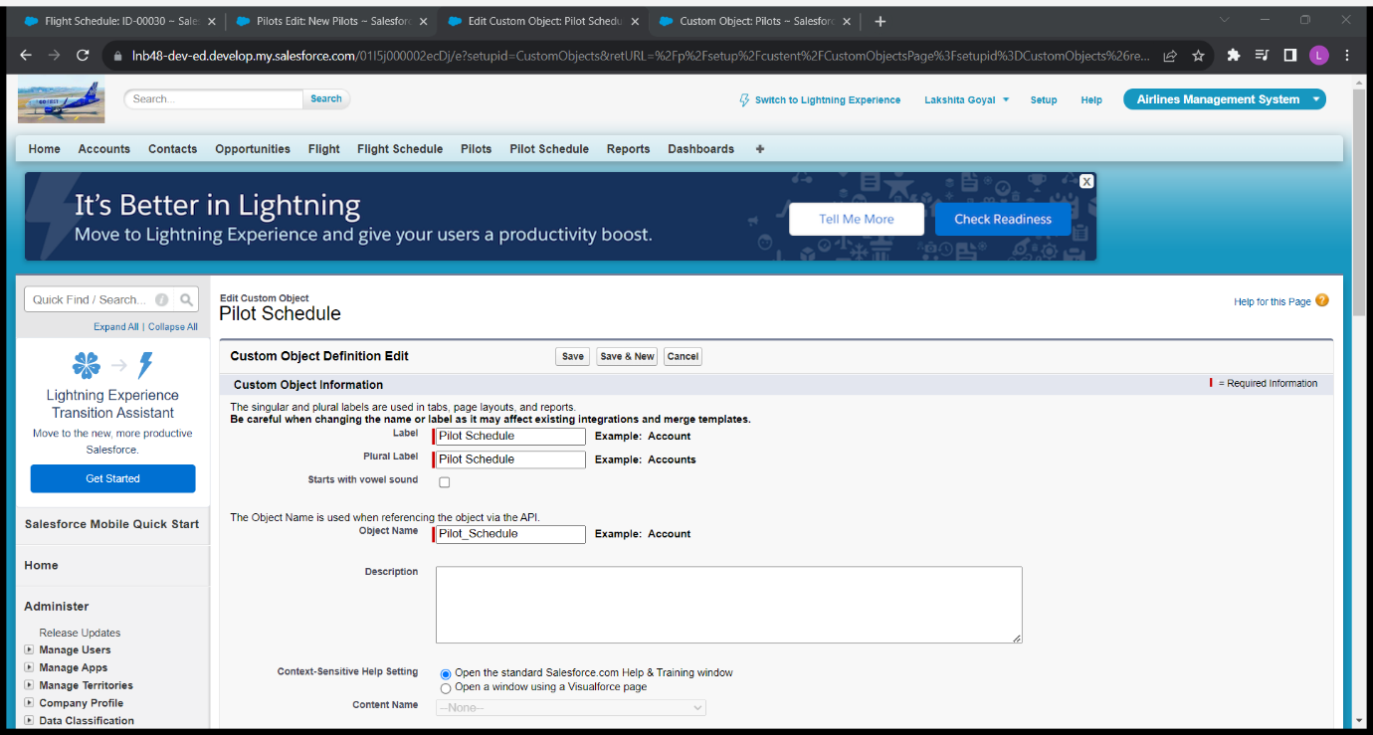

*Fig 28: Pilot Schedule Object*

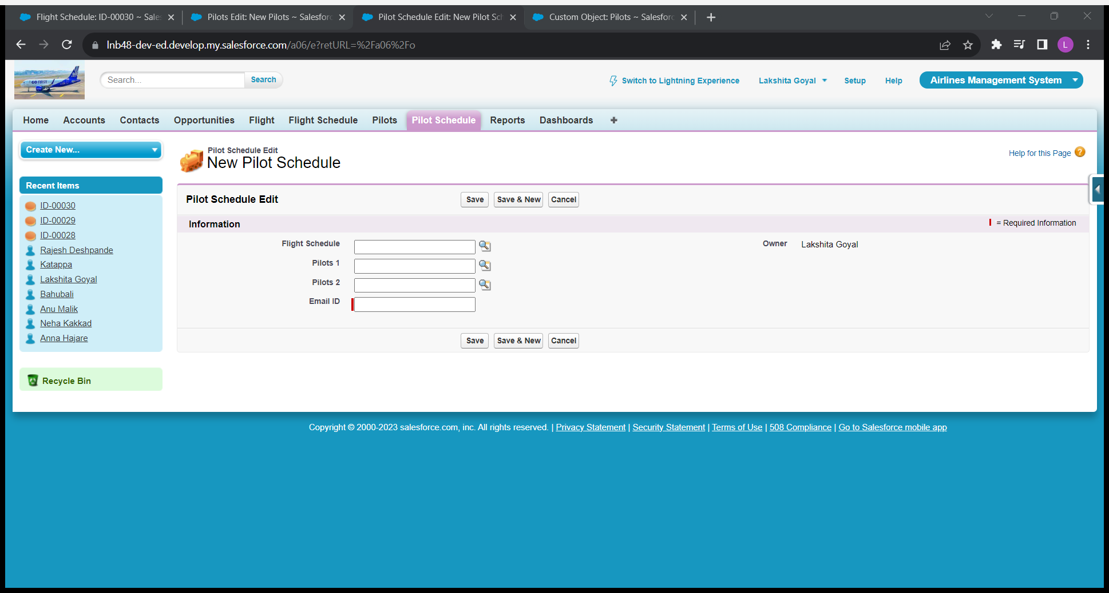

*Fig 29: Design of Pilot Schedule*

A] Create a dashboard which shows scheduled flight on today’s=

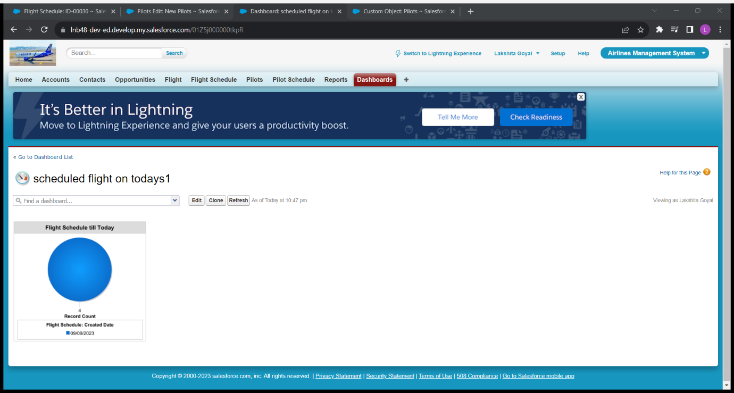

*Fig 30: Dashboard, graph for scheduled flight on today’s*

B] Create a dashboard which shows scheduled flight on month-wise=

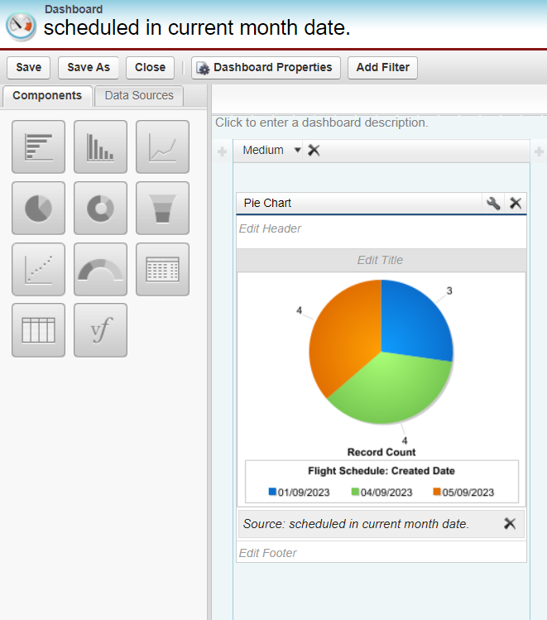

*Fig 31: Dashboard which shows the Flight according to month wise*

C] Create a Pi chart with shows total closed and Cancelled flight=

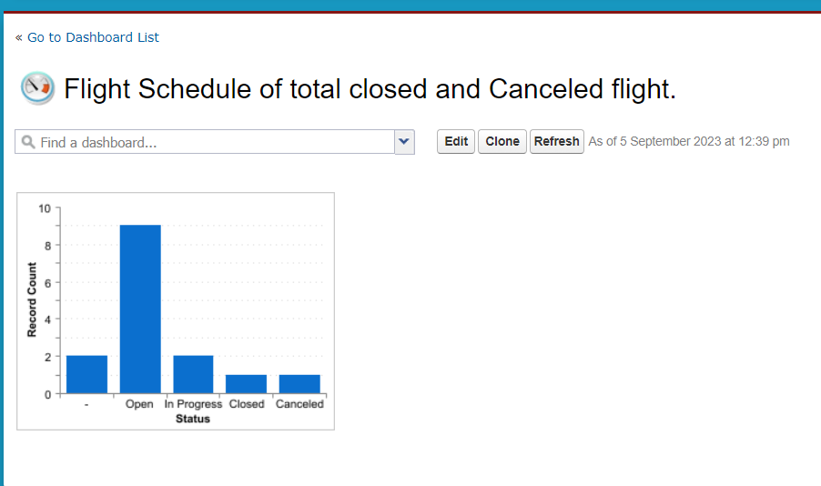

*Fig 32: Graph that shows total CLOSED and CANCELLED Flight*

D] Create a report to show flights and its all scheduled till date=

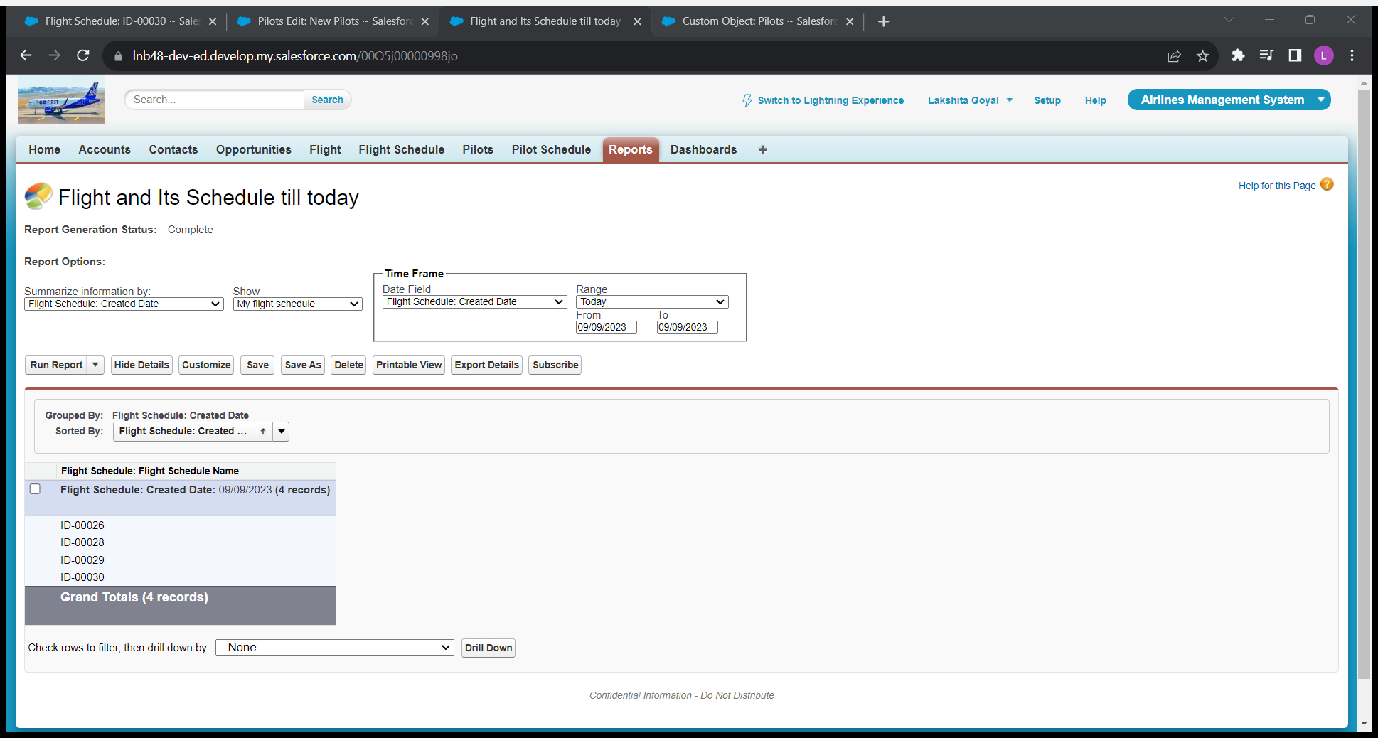

*Fig 33: Report to show flights and its schedule till date*

*E] Create a report to show flights and its all scheduled in current month date=*

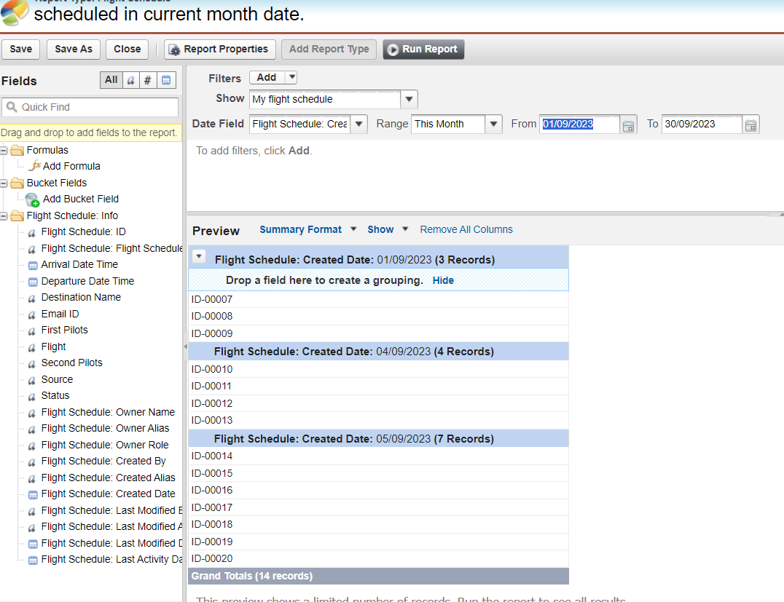

*Fig 34: Report to show flights and its all schedule in current month date*

F] Create a report to show flights and its all scheduled in last 03 months=

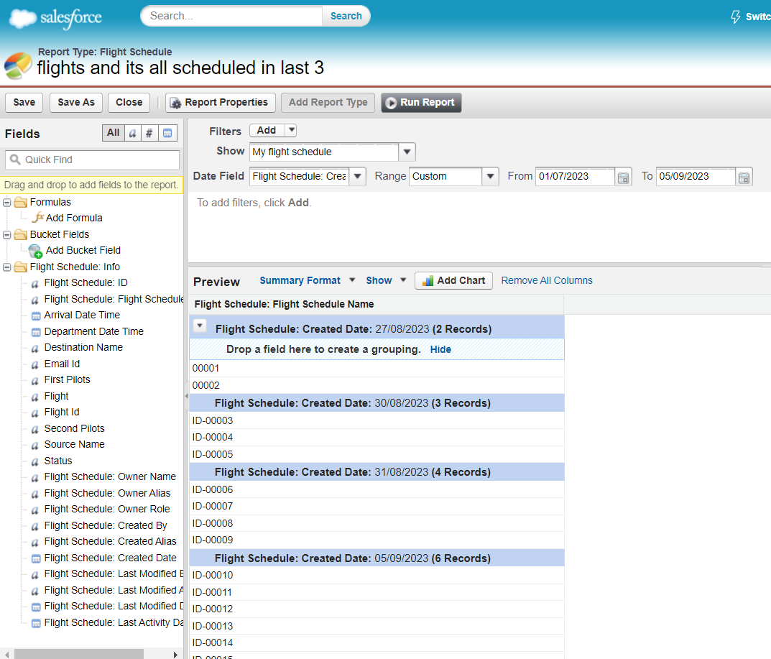

*Fig 35: Report to show flights and its all schedule in last 03 months*

**7] USERS=**

A] Create users Rajesh Deshpande, Anna Hajare, Neha Kakkad, Anu Malik, Katappa and Babubali=

1. Rajesh Deshpande=

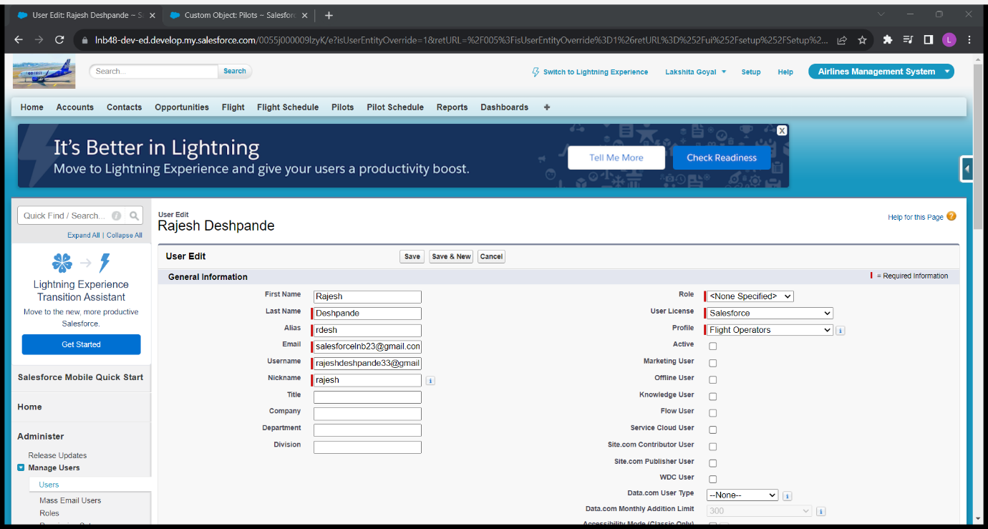

*Fig 36: Create User Rajesh Deshpande*

1. Anna Hajare=

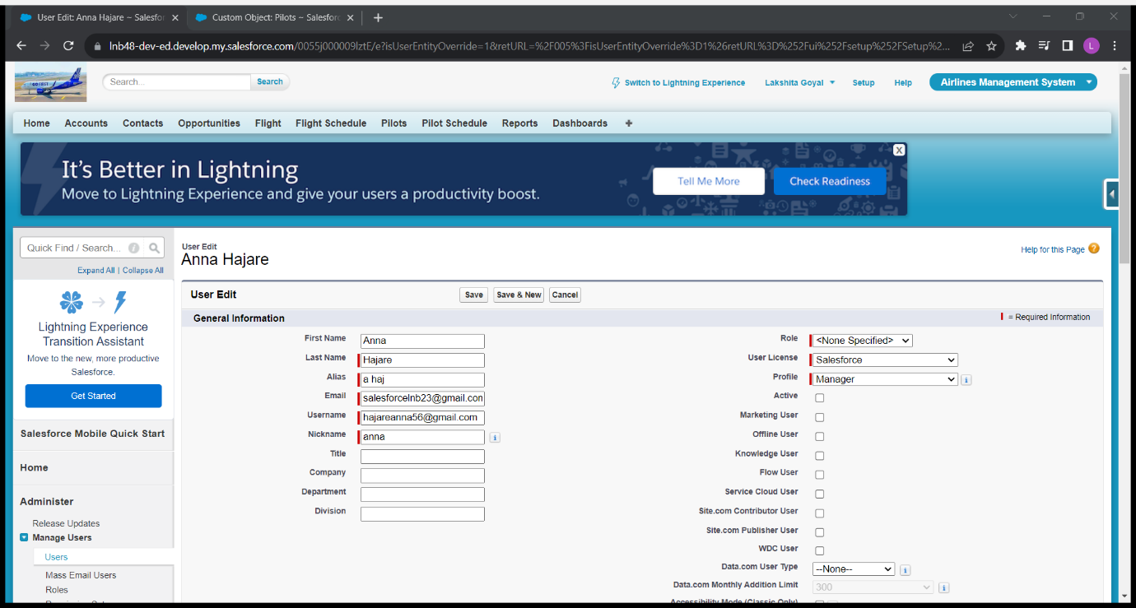

*Fig 37: User Anna Hajare*

1. Neha Kakkad=

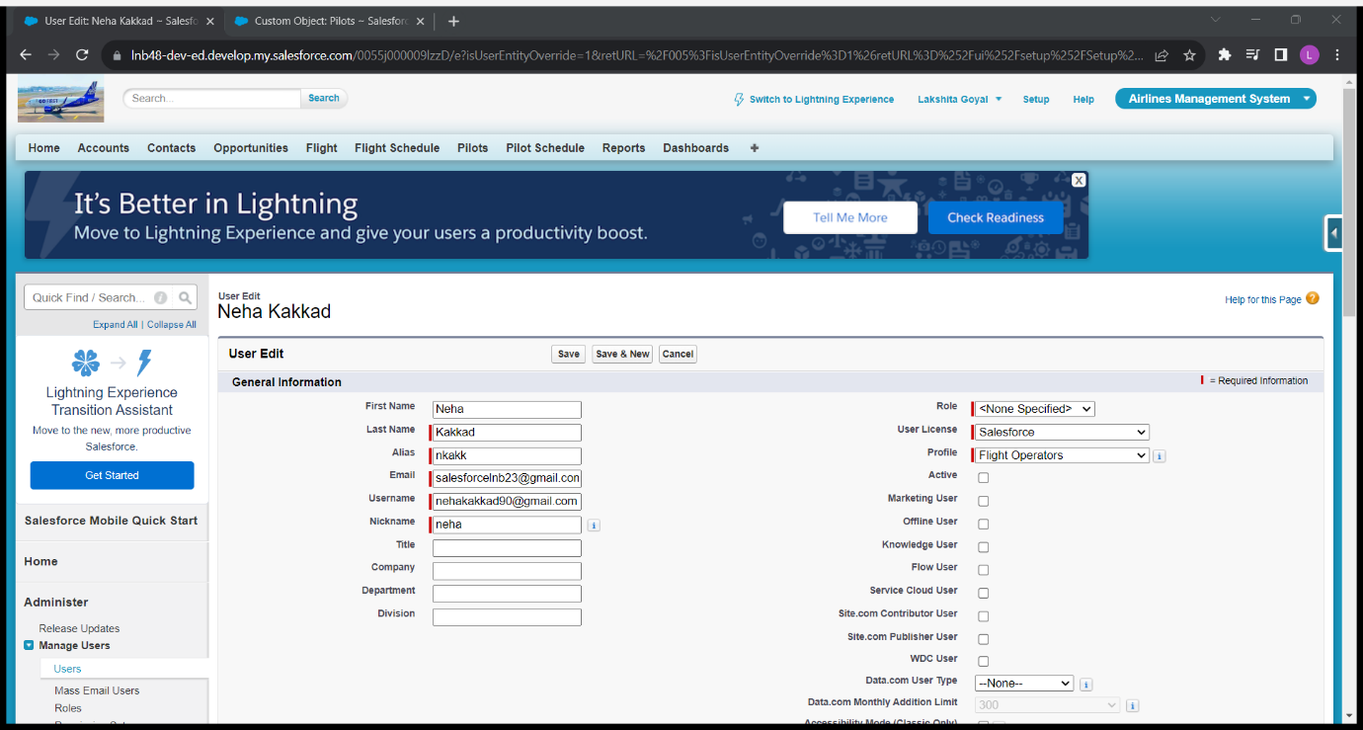

*Fig 38: User Neha Kakkad*

1. Anu Malik=

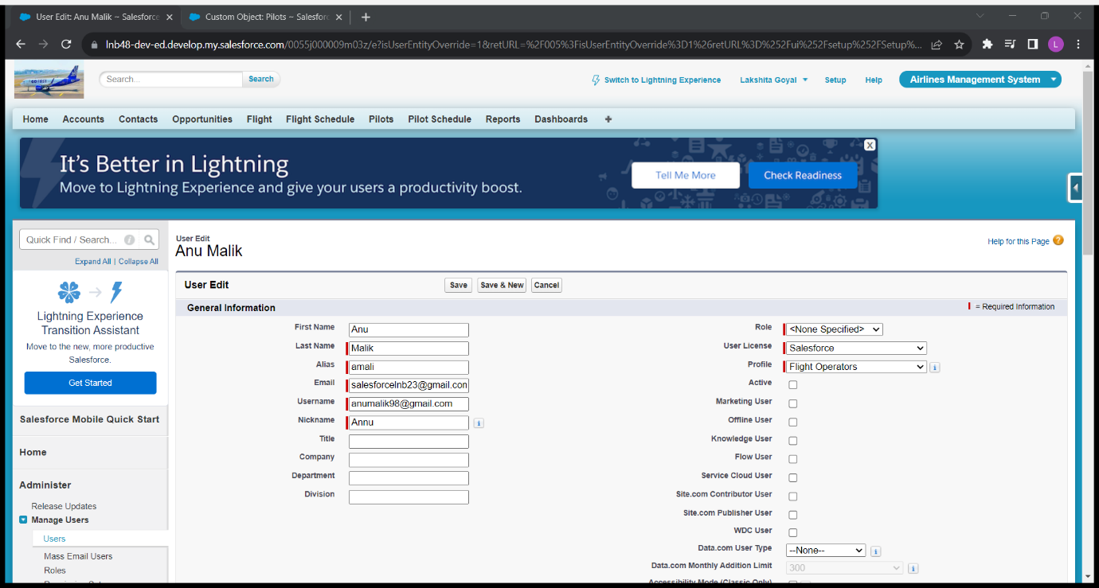

*Fig 39: User Annu Malik*

1. Katappa=

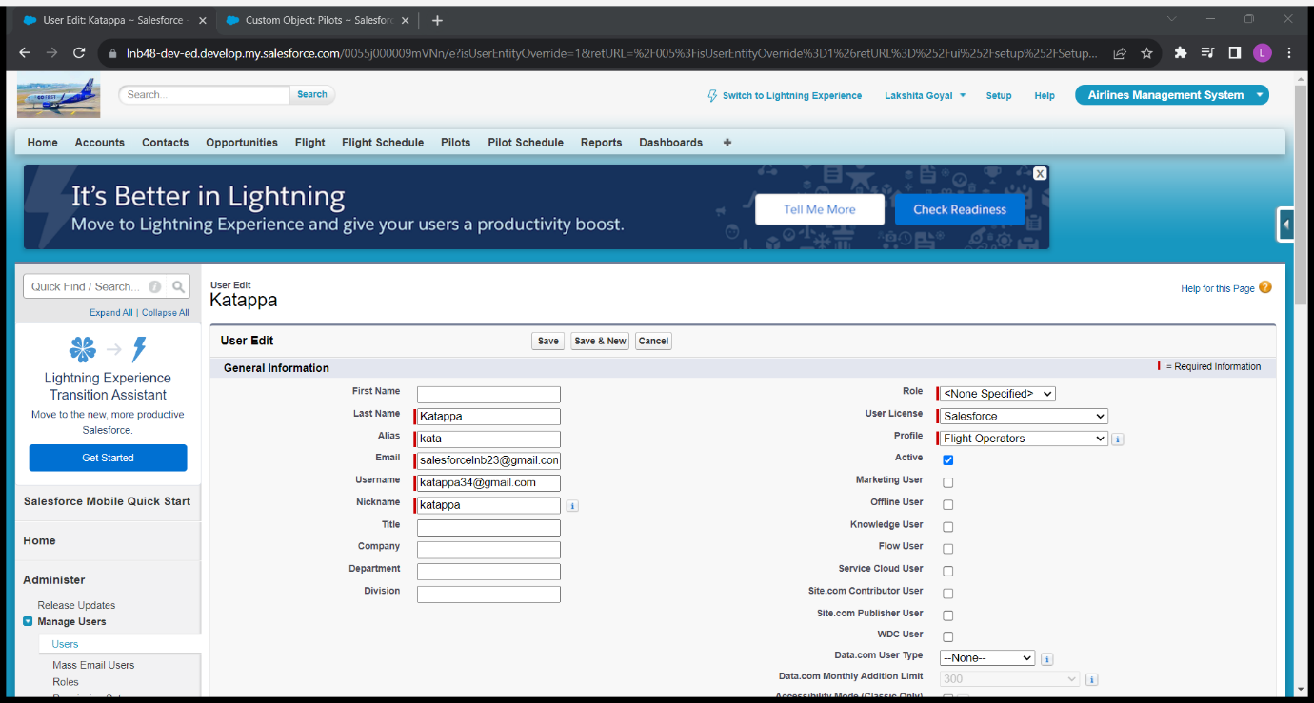

*Fig 40: Katappa*

1. Babubali=

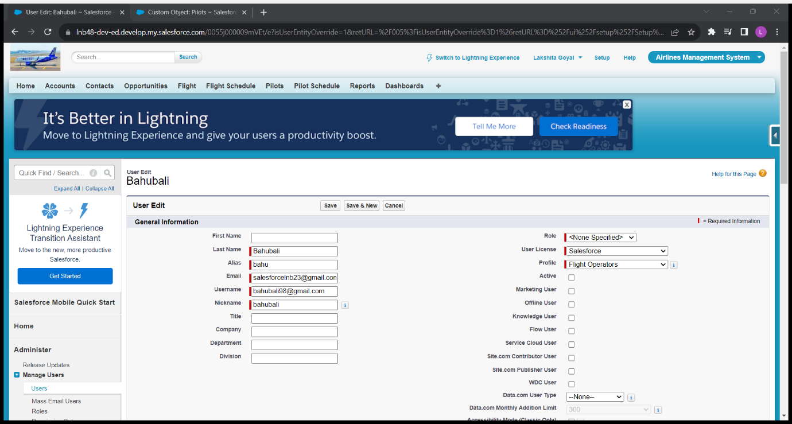

*Fig 41: Bahubali*

B] System Admin is CEO=

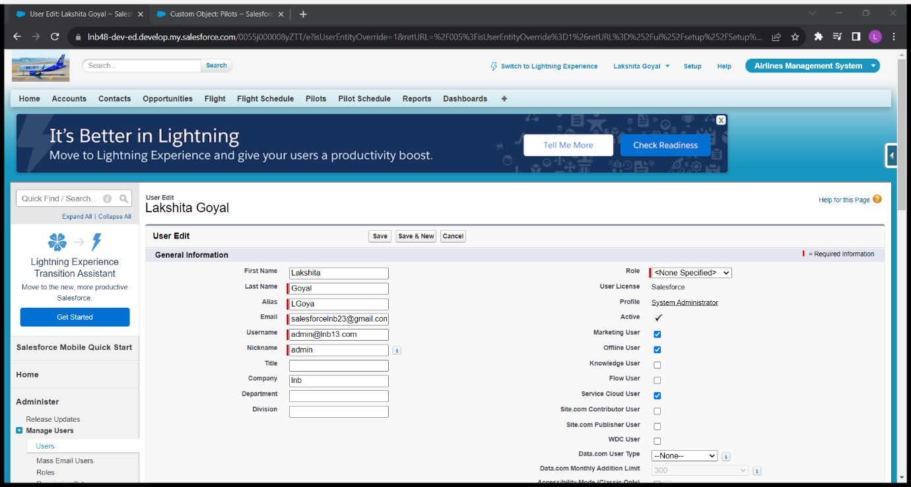

*Fig 42: System Admin CEO*

C] Anna Hajare is Manager=



*Fig 43: Manager is Anna Hajare*

D] Rajesh Deshpande, Neha Kakkad and Anu Malik are Flight Operators=

a. Rajesh Deshpande=



*Fig44: Flight operator Rajesh Deshpande*

b. Neha Kakkad=



*Fig 45: Flight operator Neha Kakkad*

c. Anu Malik=



*Fig 46: Flight operator Anu Malik*

E] All the operator reports to Anna Hajare and Anna Hajare reports to CEO=

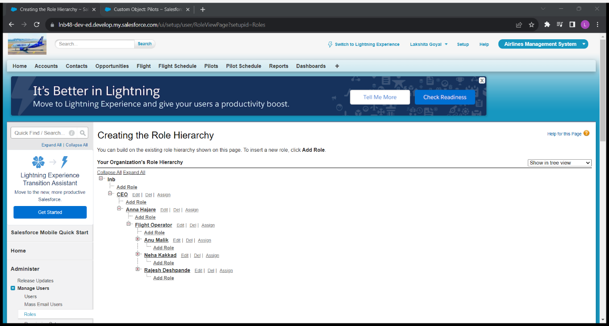

*Fig 47: All flight operator will report to Anna Hajare and Anna Hajare will report to CEO*

F] All the operators and create read and edit the data, BUT only Rajesh Deshpande can delete any record=

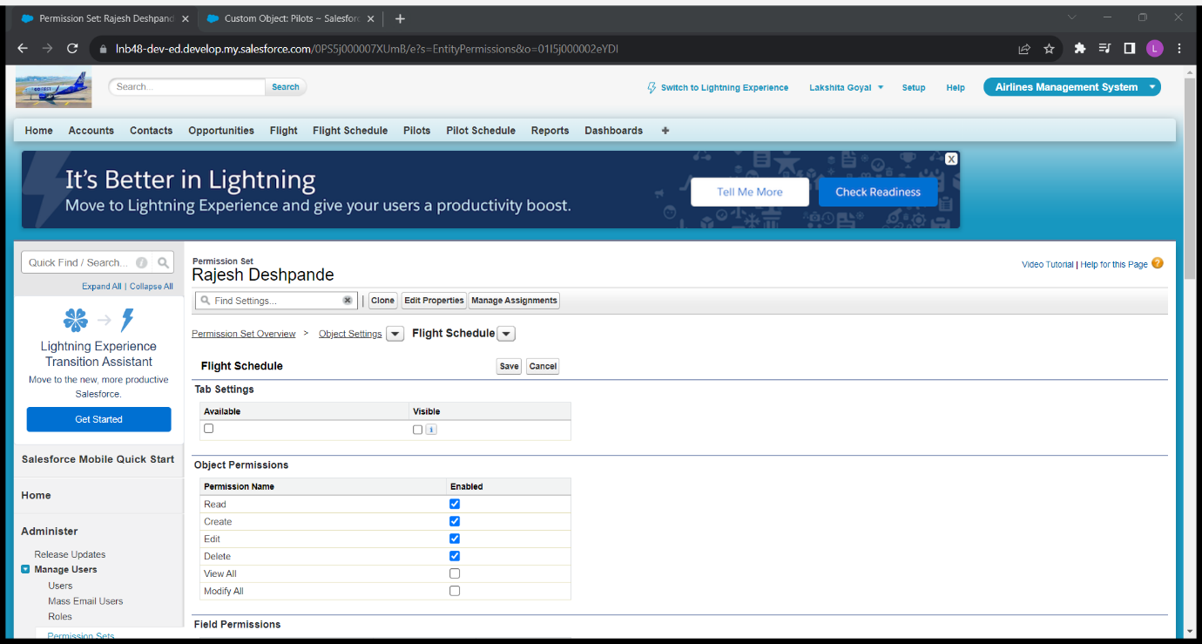

*Fig 48: Only Rajesh Deshpande can delete the record*

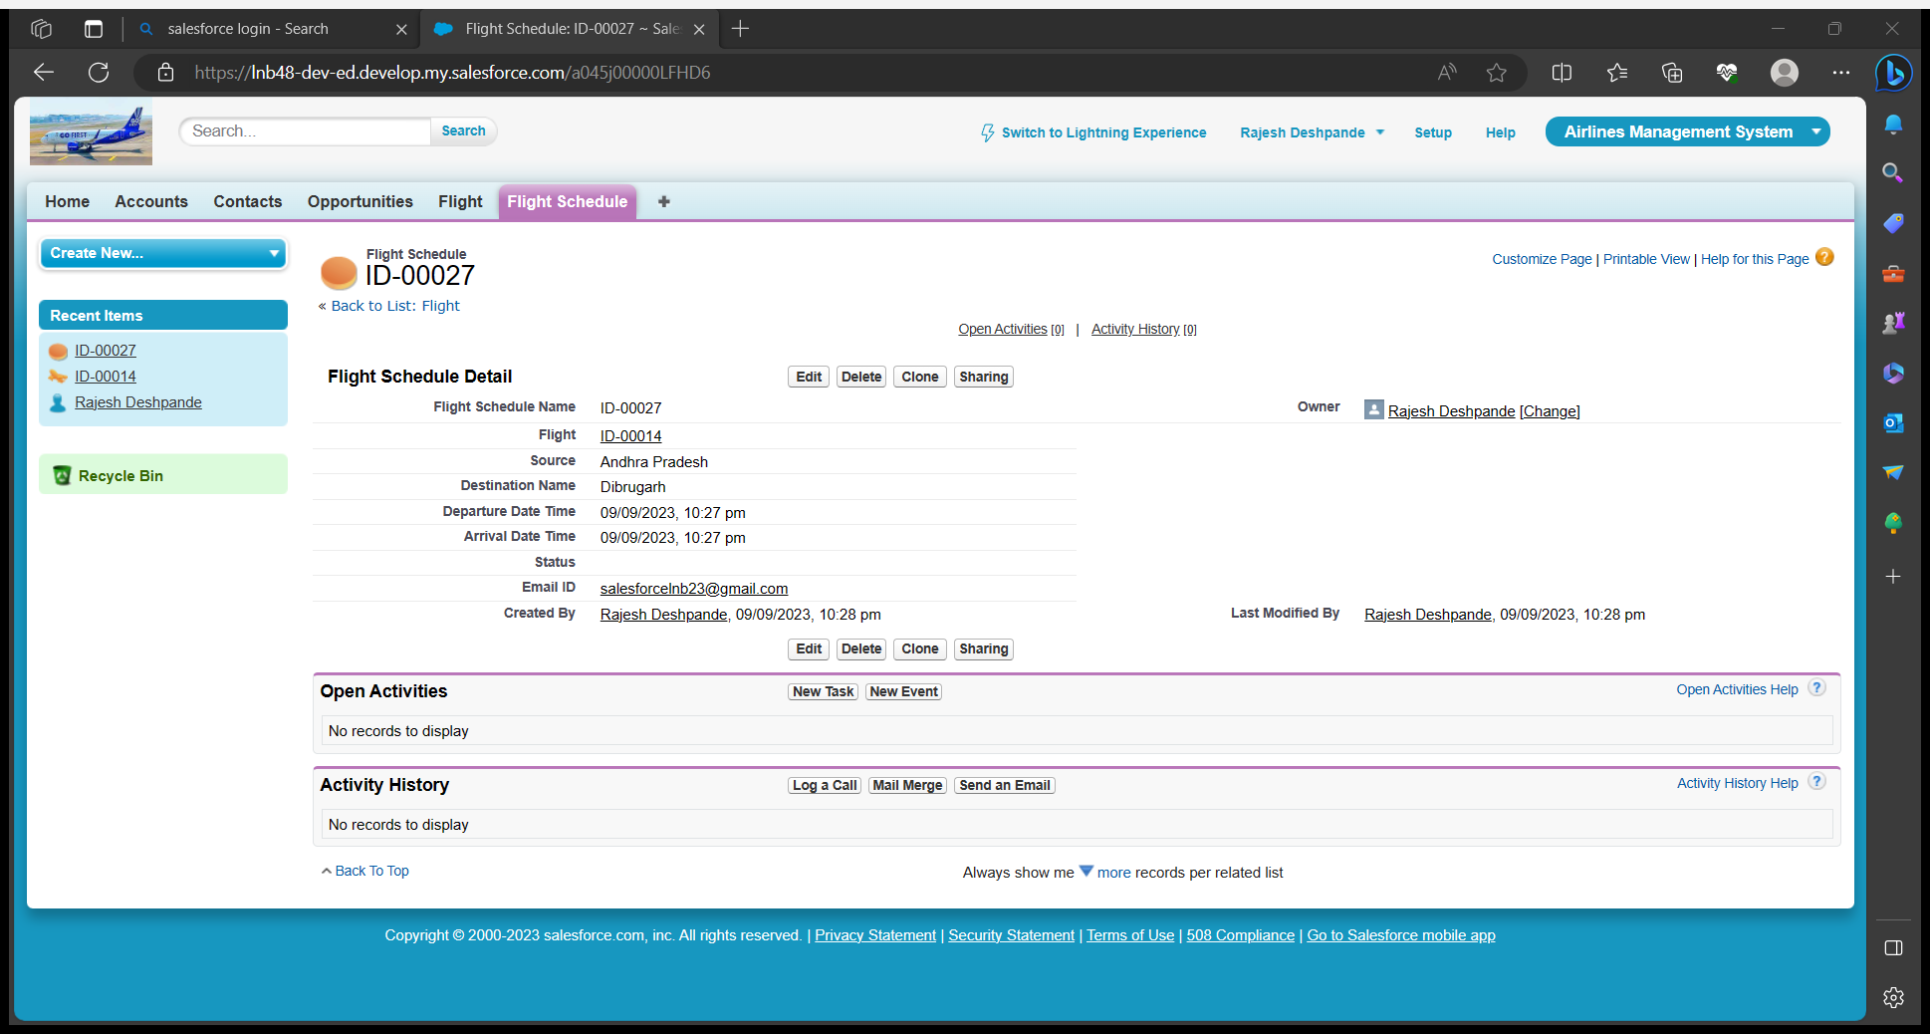

*Fig 49: Rajesh Deshpande delete any record*

H] Create a public folder Mumbai and Pune. Add Katappa to Mumbai public folder and Bahubali to Pune folder=

a. Mumbai Folder(Katappa)=

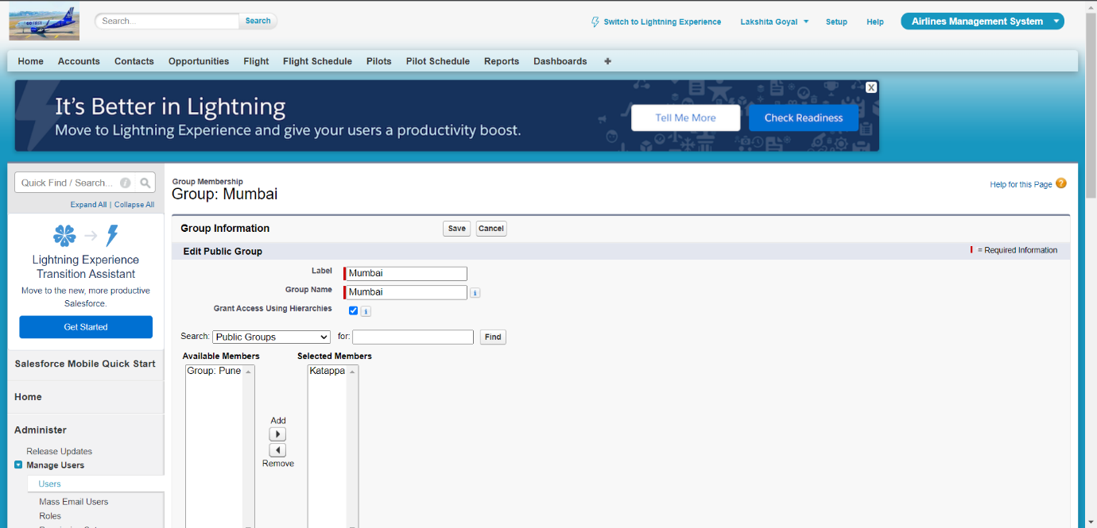

*Fig 50: Katappa can show the record of Mumbai public folder*

b. Pune Folder(Bahubali)=

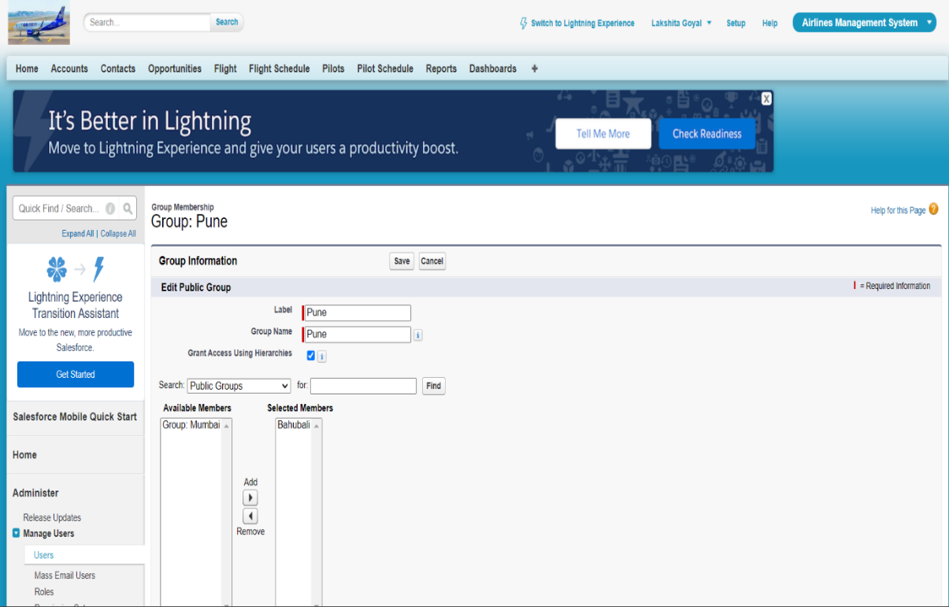

*Fig 51: Bahubali can show the record of Pune public folder*

I] When a flight is arriving to Mumbai, then share this flight record with Katappa=

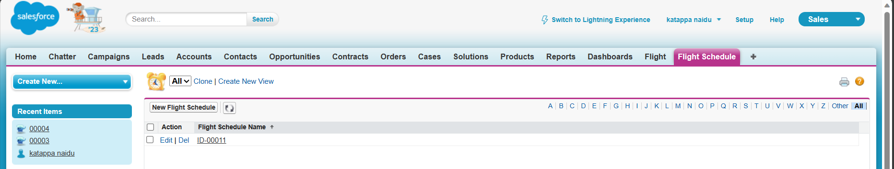

*Fig 52: When arrive to Mumbai the record can only be shown by Katappa*

J] When a flight is arriving to Pune, then share this flight record with Bahubali=

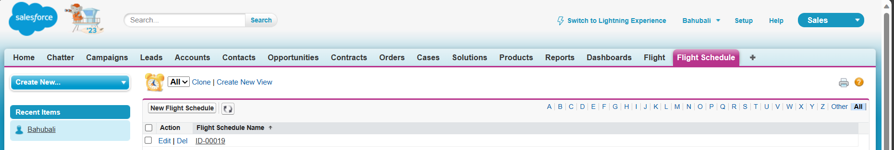

Fig 53: *When arrive to Pune the record can only be shown by Bahubali*

**Conclusion**

In conclusion, the implementation of the Airline Management System during the Salesforce Development Industrial Training has proven to be a significant advancement in the efficient management of airline operations.

This system addresses several challenges traditionally faced by the aviation industry, providing an automated and streamlined solution for managing flights, passengers, and bookings. By incorporating features such as user-friendly interfaces, robust database management, and real-time flight scheduling, the system has greatly enhanced accessibility, improved operational accuracy, and elevated the overall user experience for both administrators and passengers.

One of the notable outcomes of this project is the reduction of manual tasks, allowing airline staff to focus on strategic tasks such as customer service and operational optimization, rather than routine administrative processes. The system’s automation has minimized errors in ticket booking and seat allocation while providing a seamless customer experience.

Additionally, the powerful reporting capabilities offer valuable insights into flight performance, passenger trends, and revenue generation, enabling data-driven decision-making to optimize resources and improve efficiency.

Feedback from users during testing has been overwhelmingly positive, highlighting the system’s ease of use, efficient booking processes, and real-time notifications for flight updates. The integration of customer communication channels, such as email alerts for flight changes and booking confirmations, has enhanced the airline’s engagement with its customers, ensuring a smoother, more responsive service.

Looking ahead, the Airline Management System can be continuously improved and expanded to meet evolving business needs. Regular updates and maintenance will be essential to addressing emerging challenges and leveraging new technologies. The system’s scalability provides the foundation for future enhancements, such as incorporating artificial intelligence for predictive maintenance and customer service automation, as well as advanced analytics for revenue forecasting.

In summary, the Airline Management System stands as a successful endeavor in modernizing airline operations within the Salesforce platform. It not only simplifies administrative tasks but also enhances the overall travel experience for passengers and staff alike. This project demonstrates the potential of technology-driven innovation, offering a solid foundation for continued growth and adaptation in the fast-evolving aviation industry.